**Investment Tracker & Analysis.**

**A Project Report**

Submitted in partial fulfillment of the

Requirements for the award of the Degree of

**BACHELOR OF SCIENCE (INFORMATION TECHNOLOGY)**

**By**

Karambalkar Yash Shivaji

219645

**Under the esteemed guidance of**

**Dr.HirenDand**

**Coordinator, Department of Information Technology**

**DEPARTMENT OF INFORMATION TECHNOLOGY**

**ParleTilakVidyalaya Association’s**

**MULUND COLLEGE OF COMMERCE**

***(Affiliated to University of Mumbai)***

***NAAC Re-Accredited A Grade – III Cycle***

**MULUND WEST, MUMBAI 400080**

**MAHARASHTRA, INDIA**

**2021 – 22**

**PROJECT PROPOSAL**

|  |  |  |  |
| --- | --- | --- | --- |
|  | PRN No | : | **2019016400446817** |
|  | Roll No | : | **219645** |
|  | Name of the Student | : | **Karambalkar Yash Shivaji** |
|  | Title of the Project | : | **Investment Tracker & Analysis.** |
|  | Name of the Guide | : | **Dr. Hiren Dand** |
|  | Teaching Experience of Guide | : | **29 years** |
|  | Is this your first Submission | : | **Yes** |



Signature of the Student Signature of the Coordinator

Date: 20/06/2021 Date: October 7, 2021

**ACKNOWLEDGEMENT**

To list who all have helped me is troublesome in light of the fact that they are so various and the profundity is so tremendous.

I would like to acknowledge the accompanying as being hopeful directs and new measurements in the fulfillment of this venture.

I make a move to thank the University of Mumbai for allowing me opportunity to do this venture.

I would like to thank my Principal, **Dr. Sonali Pednekar** for giving necessary facilities required for completion of this venture.

I make a move to thank our Coordinator **Dr.HirenDand** for her ethical help and direction.

I might likewise want to offer my genuine thanks towards teaching faculty whose direction and care made the undertaking effective.

I would like to thank my College Library, for having given different reference books and magazines readily available on college website.

Ultimately, I might want to thank every single individual who straightforwardly or in a roundabout way helped me in the fruition of the task particularly my Parents and Peers who upheld me all through my undertaking.

**ABSTRACT**

Socially responsible investing is generally considered as investments that would upgrade ecological, social, and monetary manageability. These investments into projects or legitimate substances commonly distribute assets into the turn of events and presenting of items and administrations that are considered socially responsible with an emphasis on long haul financial premium. Institutions occupied with socially responsible investing are intended to keep away from organizations that are ethically sketchy and associated with items and administrations that would bring about impracticality of the climate and society. Certain business exercises specifically cause contamination to the climate and antagonistically influence human wellbeing. These exercises would produce outer expenses or antagonistic effects on the wellbeing and manageability of the general public, be that as it may, not caused inside by these substances (Sovacool and Linnér 2016). Socially responsible investing has an immediate and long haul linkage with feasible advancement as it decides how financial assets are changed over into monetary and business exercises for manageable improvements of the world that we live in. Socially responsible investing is likewise frequently alluded to as supportable investing. These investments think about issues relevant to natural manageability, social responsibility, and governance (ESG). Such coordinated thought empowers financial backers to look for investments that are synergistic with both financial targets and characteristic upsides of ESG (Hopwood et al. 2010).

**CONTENTS**

|  |  |  |
| --- | --- | --- |
| 1.0 | Introduction |  |
| 1.1 | Monetary and Economic Meaning of Investment |  |
| 1.2 | A few factors that have settled on investment choices progressively significant are |  |
| 1.3 | Factors Convenient for Investment |  |
| 1.4 | Investment Channels |  |
| 1.5 | What are the Various Risk Involved in Investment? |  |
| 1.6 | The distinction between Investment and Speculation |  |
| 1.7 | Stock Market |  |
| 1.8 | Stock Exchange |  |
| 1.9 | 4 Main attributes of Stock Exchange |  |
| 2.0 | Review Of Technologies |  |
| 2.1 | What is Python |  |
| 2.2 | Python in Real World |  |
| 2.3 | Asynchronous Programming in Python. |  |
| 2.4 | Asynchronous Python |  |
| 2.5 | Python 2 Finish of life: What it implies? |  |
| 2.6.1 | Assignment expressions. |  |
| 2.6.2 | Positional-only parameters. |  |
| 2.6.3 | F-String debugging support. |  |
| 2.7 | Multiprocessing Shared Memory. |  |
| 2.8 | Composing module upgrades |  |
| 2.9 | The new version of the pickle convention |  |
| 2.10 | Execution upgrades |  |
| 2.11 | Python C API and CPython improvements |  |
| 2.11.1 | An Introduction to Pandas |  |
| 3.0 | Software Requirement Specifications |  |
| 3.1 | Problem Defination |  |
| 3.2 | Requirement Specification |  |
| 3.3 | Planning and Scheduling |  |
| 3.4 | Software Requirements |  |
| 3.5 | Hardware Requirements |  |
| 3.6 | Resource Management System ER Diagram |  |
| 4.0 | Visual Representation |  |
| 4.1 | About AWS (Amazon Web Services) |  |
| 4.1.1 | Benefits of using AWS |  |
| 4.2 | Vital Security |  |
| 4.3 | Basic Modules |  |
| 4.4 | Representation of GUI for Website. |  |
| 4.5 | Working of Application. |  |
| 4.6 | Exceptions |  |
| 5.0 | References |  |

**Chapter 1**

***Introduction***

Investment is crafted by the resource's complete purpose on achieving additional compensation or improvement in regard. The basic idea of an investment is that it incorporates 'holding on' for an honor. It incorporates the obligation of resources that have been saved or dealt with from current use with the assumption that a couple of benefits will assemble in the future. The term 'Investment' doesn't radiate an impression of being just probably as direct as it has been described.

Investment has been arranged by money-related subject matter experts and business examiners. It has moreover routinely been confused with the term hypothesis. The going with discussion will give an explanation of the various habits by which investment is associated or isolated from the money-related and monetary sense and how theory contrasts from investment. It ought to be clearly settled that investment incorporates long stretch liability.

* 1. **Monetary and Economic Meaning of Investment:**

Investment is the assignment of financial resources for assets that are depended upon to yield some expansion or positive return all through a given time span. These assets range from safe investments to perilous investments. Investments in this design are moreover called 'Financial Investments'.

As indicated by the viewpoint of people who contribute their resources, they are the suppliers of 'Capital' and in their view, investment is an obligation of a singular's resources for deciding future compensation as income, benefits, rent, costs, annuity benefits, or the excitement for the value of their focal capital.

To the financial patron, it isn't huge whether money is contributed for a helpful use or for the obtaining of reused instruments, for instance, existing offers and stocks recorded on the stock exchanges. Most investments are seen as moves of financial assets beginning with one individual then onto the following.

The possibility of investment in the financial sense fluctuates from its use in the money-related sense. To the financially trained professional, 'Investment' means the net augmentations to the economy's capital stock which involves products and organizations that are used in the formation of various work and items. The term investment recommends the advancement of new and valuable capital as a new turn of events, new producers' intense stuff like plant and equipment. Inventories and HR are associated with the financial master's significance of investment.

The financial and money-related significance of investment is related to each other because investment is a piece of the hold assets of individuals which stream into the capital market either clearly or through associations, isolated in 'new' and reused capital financing. Financial benefactors as 'suppliers' and financial patrons as 'customers' of long stretch funds find a get-together spot watching out. In this book, regardless, the investment will be used in its 'financial sense' and investment will fuse those instruments and institutional media into which save reserves are set.

* 1. **A few factors that have settled on investment choices progressively significant are:**

Longer future or preparing for retirement, growing speeds of expense assortment, extreme financing costs, high speed of enlarging, greater income, and openness of a confounding number of investment outlets.

1. **Taxation:**

Tax assessment is one of the critical components in any country which presents a component of impulse in an individual's reserve funds. There are different types of reserve funds outlets in our country as investments which help in cutting down the expense level. These are examined under the accessibility of investment media.

1. **Longer Life Expectancy:**

Investment choices have become huge as individuals resign between the age of 60 and 65. Additionally, the pattern shows a longer future. The profit from business ought to be determined in such a way that a part is taken care of as investment funds. Reserve funds without anyone else don't expand riches; these should be put resources into such a way that the head and pay will be satisfactory for a more noteworthy number of retirement years.

The significance of investment choices is improved by the way that there is an expanding number of ladies are working in associations.

People will be answerable for arranging their own investments during their functioning life so that after retirement they can have steady pay. Expansion in the functioning populace, legitimate making arrangements for life length and life span have guaranteed the requirement for adjusted investments.

1. **Inflation:**

Each creating economy is staged with the issue of rising costs and inflationary patterns. In India, inflation has turned into a nonstop issue since the last decade. In these long stretches of rising costs, a few issues are related combined with a falling way of life. Before reserves are contributed, the disintegration of the assets should be painstakingly thought to be to settle on the ideal selection of investments. The financial backer will attempt to look through an outlet that will give him a high pace of return as an interest to cover any abatement because of inflation. He will likewise need to decide whether the interest or return will be persistent or there is a probability or unpredictability.

1. **Interest Rate:**

The degree of loan costs is another perspective that is essential for a sound investment plan. Financing costs shift between one investment and another. These might change among unsafe and safe investments; they may likewise contrast because of various advantage plans presented by the investments.

These perspectives should be considered prior to dispense any sum in investments. A high pace of revenue may not be the main factor preferring the source for investment. The financial backer needs to remember for his portfolio a few sorts of investments. He/she should keep a portfolio with high danger and exceptional yield just as a generally safe and low return. The steadiness of premium is pretty much as significant as getting a high pace of interest. This book is worried about establishing that the financial backer is getting a satisfactory return proportionate with the dangers that are taken.

1. **Revenue:**

Investment choices have expected significance due to the overall expansion in work open doors in India. The phases of improvement in the nation have sped up requests and various new associations and administrations have expanded.

Occupations are accessible in new areas like programming innovation; business preparing workplaces, call focuses, trades, media, the travel industry, neighborliness, producing area, banks, protection, and financial administrations. The business openings led to expanding earnings. More wages have expanded interest for investments to get more pay over their ordinary pay. The various roads of investments can be chosen to help the customary pay. The consciousness of financial resources and genuine resources has prompted the capacity and eagerness of working individuals to save and put their assets for return in their lean period prompting the significance of investments.

Consequently, the destinations of investment are to accomplish a decent pace of return, later on, diminishing danger to get a decent return, liquidity on the schedule of crises, security of assets by choosing the right roads of investments, and support against inflation.

* 1. **Factors Convenient for Investment:**

The investment market should have an optimal environment to have the choice to work effectively. Business practices are separated by cordial, money-related, and political considerations. It is critical that the money-related and political parts are acceptable.

Generally, there are four essential thoughts that develop improvement and bring openings for investment. These are real safeguards, stable cash, and the presence of financial foundations to assist with holding assets and kinds of business affiliation.

1. **Legal Precautions:**

A steady government that outlines satisfactory lawful protections empowers the collection of reserve funds and investments. Financial backers will actually want to contribute their assets in the event that they have the confirmation of security of their legally binding and property rights.

In India, the financial backers enjoy the double benefit of free venture and control. Opportunity, proficiency, and development are guaranteed from the serious powers of private endeavors. Legal control applies discipline and shortens some components of opportunity. In India, the political environment is helpful for investment since the new financial changes in 1991 prompting progression and globalization.

1. **Well Constructed Currency:**

An efficient money-related framework with unmistakable arranging and legitimate arrangements is essential to an investment market. The vast majority of the investments, for example, bank stores, extra security, and shares are payable in the cash of the country.

A legitimate money-related strategy will provide guidance to the investment outlets. Quite far, the money-related strategy ought to neither advance intense inflationary pressing factors nor plan for a flattening model. Neither one of the conditions is palatable.

Value inflation obliterates the buying force of investments. Frugality is likewise punished when the net revenue after charges got by the financial backer is not exactly the ascent in the value level, leaving the financial backer with less all-out buying power than he had at the hour of saving.

1. **Presence of Financial Institutions and Services:**

The presence of financial establishments and financial organizations invigorate hold reserves, direct them to valuable uses, and helps the investment market to create. The financial establishments in presence in India have shared resources, headway banks, business banks, additional security associations, investment associations, investment agents, and home credit financial backers.

The financial organizations fuse subsidizing, ascertaining and forfaiting, leasing, utilize purchase and customer finance, dwelling finance, seller financial backers, and the portfolio the board. Investment financial backers are merchants of insurances. They buy bonds and heaps of associations for re-arrangement to financial benefactors. The investment financial backers are perceived by security agents who go about as experts in buying and selling recently gave assurances for commission. Home credit lenders on occasion go about as sellers and occasionally as experts on agreement progresses usually on private properties.

They fill in as specialists among financial supporters and borrowers and perform ensure organization in regards to signs of progress. Business banks and financial establishments also go probably as home advance intermediaries in giving home advance credits and changing the advances. In India, there are a colossal number of financial establishments under Central Government and State Governments, and rural bodies that have upheld the advancement of hold assets and investment. The Life Insurance Corporation and Unit Trust of India offer a wide variety of plans for investment assets and give tax reductions as well. Besides these, there is a proficient association of progress banks, for instance, the Industrial Development Bank of India (IDBI), Industrial Credit Investment Corporation of India (ICICI), and Industrial Finance Corporation of India (IFCI).

At the state level, there are State Financial Corporation, for country locales and agribusiness, the National Bank of Agriculture and Rural Development (NABARD). These financial establishments and headway banks offer a wide combination of approaches for engaging store assets and investment. These establishments advance a part of fortitude to the capital market and advance discipline while enabling turn of events.

Since 1991, there has been an improvement in the private corporate region. Various new financial establishments have emerged in the private region. Insurance associations, shared resources, and financial backers leasing associations have been opened up to private financing workplaces. New banks have been allowed to cooperate. Consequently, there is the presence of incalculable foundations and organizations which redirect the resources helpfully.

1. **Type of Business Organization:**

The sort of business affiliation which is amazingly strong in the presence of colleagues saves assets and investment. The public limited associations have should be the best kind of affiliation. The three credits of the organization which have been particularly useful for financial supporters are the confined danger of financial backers, relentless life and flexibility, and noticeability of stocks and shares. The public limited association with the ability to continue with its business paying little mind to people containing it gives life range and adequacy to its business development.

Rather than a public limited association whose financial backers have confined danger, the sole proprietor or an assistant in an affiliation firm is liable for all of the commitments of the firm to the full level of his own wealth. In these conditions, financial sponsors are hesitant to risk their investment assets in these kinds of affiliations.

Other than boundless danger, the affiliation and proprietor furthermore experience the evil impacts of the short presence of the affiliation. With the destruction or retirement of any of the assistants, an affiliation firm has deteriorated. Moreover, a sole proprietor carries on business simply during his lifetime.

In these insecure and dubious conditions, financial supporters might not have any desire to make their investments. Finally, the public confined association credits a part of liquidity to its shares. Then again, association limits strength and flexibility uninhibitedly starting with one individual then onto the next. The public limited association, thusly, is a well-known design for investment as the financial patrons' advantage from liquidity, solace, and life expectancy.

In India since 1991, there is the presence of colossal corporate affiliations. There have been various unions and mixes and the blend has happened.

The business has become all the more dependable in nature. Secretly run organizations have broadened and are at present consistent and effective. Indian business is taking new constructions and being seen in the world. With extended care and strength, the financial sponsor has various ideal hotspots for making investments.

1. **Option Of Investment:**

The turn of events and progression of the country provoking more unmistakable financial development has incited the introduction of a tremendous scope of investment outlets. Besides setting to the side save assets available for later finances banks where the premium is low, financial sponsors have the choice of a combination of instruments. The request to reason out is which is the most proper channel? Which media will give a sensible turn of events and security of return?

The financial sponsor in his choice of investment should endeavor to achieve a real mix between the high speed of return and security of return to get the prizes of both. A piece of the instruments open is esteem shares and protections, lucky resource, catastrophe security, fixed stores, and normal backings plans.

1. **Low-Risk Vs. High-Risk Investment:**

Most financial benefactors are peril hesitant anyway they expect the most noteworthy return from their investment. Every investment ought to be inspected considering the way that there is positively some risk in it. The Indian investment scene has many designs to bring to the table to an individual. On an examination of these plans, obviously, the financial supporter has a wide choice.

A massive extent of investments is in the public position region. These are by and large risk-free anyway low bring yielding back. A couple of persuading powers are joined to it. The private region investments contain worth and tendency shares, debentures, and public stores with associations. These have the parts of high risk. Finally, the financial patron should make his investment decisions. The issue looked at by the Indian financial benefactor is the trade-off of efficiency, liquidity, and risk of investments. Government assurances are without danger and the financial sponsor is gotten. Nevertheless, to him, the return or yield is indispensable as he has limited resources and should plan energy for the investments for his future requirements. Government securities give low returns and don't fulfill his objective of money appreciation.

Private region insurances are engaging in any case, risky. The instances of defeating affliction of Reliance, Infosys, Wipro accommodate the financial patron the dream of future excitement for investment by a couple of times. The worldwide and blue-chip associations offer astoundingly high speeds of return and moreover give additional shares to their financial backers. Food Specialties Limited, Cadburys, Colgate Palmolive, Hero-Honda have been known to raise the assumptions for financial benefactors by giving high speeds of return.

Land and Gold partake in the advantage of killing the impact of inflation since the worth ascents experienced by them have been particularly high. The Indian financial benefactor in this setting can't pick his investments with no issue.

A financial benefactor can help get back with the least risk suggested if he carefully examinations the information appropriated in the blueprints of exclusive organizations. Substance as the past display, name of Promoters and Board of Directors, the key activities, its business prospects, and selling strategies should be assessed before the financial supporter decides to place assets into the association.

As indicated by the viewpoint of a financial supporter, convertible protections, may under authentic conditions, show an ideal mix of exceptional yield, for the most part, protected and ability of capital appreciation.

If exclusive organizations would offer a more broad extent of investments to everybody, they would have the alternative to set up a greater piece of pubic hold reserves and at the same time, the financial supporter would be engaged to make a predominant choice. This would settle his trouble of being at the crossing point.

* 1. **Investment Channels**

In India, many kinds of investment media or channels are available for making investments. A sound investment program can be created if the financial supporter discovers more with regard to the distinctive elective investments available.

Investment media are of a couple of sorts. Some are clear and direct, others present complex issues of assessment and assessments. Some are conspicuous; others are reasonably new and unidentified. A couple of investments are fitting for one sort of financial patron and another may be proper to another person.

An authoritative objective of the financial patron is to construe a variety of investments that meet this tendency for danger and expected return. The financial benefactor will pick the portfolio which will expand his utility. Securities present a wide extent of danger-free instruments to significantly theoretical shares and debentures. From this wide reach, the financial supporter ought to pick those securities that grow his utility.

The financial sponsor, toward the day's end, has an improvement issue. He needs to pick the security which will extend his typical returns subject to explicit examinations. The investment decision is of propelling returns anyway peril taking breaking point contrasts starting with one financial supporter then onto the next.

It isn't only the advancement of a portfolio that will ensure the most raised expected return anyway it is the satisfaction of the need of the financial supporter. For instance, one financial sponsor may stand up to a situation when he requires over-the-top liquidity. He may similarly require prosperity of securities. In like manner, he should pick security with low returns. Another financial patron wouldn't worry about the high risk since he doesn't have financial issues yet he may need an uncommon yield. A particularly financial patron can put his investment assets being developed shares as he will recognize danger. Another critical idea is the attitude and cerebrum exploration of the financial patron.

A couple of financial sponsors are peevishly fit to confront difficulties; there are others who are not prepared to place assets into unsafe insurances whether or not the return is high. One financial benefactor may lean toward safe government bonds however another might place assets into blue-chip esteem shares of an association. Various elective investments exist.

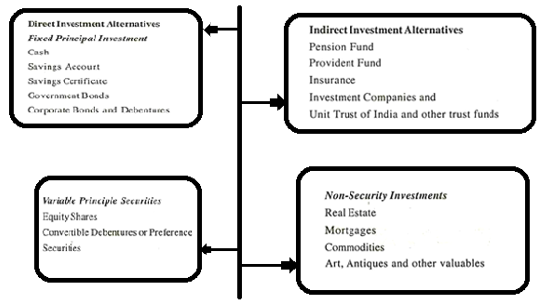

1. **Direct And Indirect Investments:**

These media choices have essentially been classified as immediate and backhanded investment choices. Direct investments are those where the singular settles on his own decision and investment choice. Roundabout investments are those wherein the individual has no immediate hang on the sum he contributes.

He contributes his reserve funds to specific associations like Life Insurance Corporation (LIC) or Unit Trust of India (UTI) and relies on them to make investments for his and others' benefit. So there is no immediate obligation or hang on to the protections.

An individual additionally makes backhanded investment for retirement benefits, as opportune assets and annuity, life coverage strategy, investment organization protections, and protections of common assets. People have no power over these investments. They are dependent on the consideration of the specific association.

The associations like Life Insurance Corporation or Unit Trust of India, fortunate assets are overseen as per their investment strategy by a gathering of trustees for the financial backer. The instances of roundabout investment options are a significant and quickly developing section of our economy. In picking explicit investments, the financial backer will require distinct thoughts in regards to various components that their portfolio ought to have.

1. **Fixed And Variable Principal Securities:**

Fixed head investments are those whose central aggregate and the terminal worth are known with affirmation. Cash has unequivocal and predictable rupee regard, whether or not it is saved in a bank or kept in a cash box. It doesn't get any return.

Ledgers have a respectable return; they contrast similar to the extended interval of time. The main aggregate is fixed notwithstanding income secured. Investment subsidies supports are extremely progressing a couple of models being public investment finances verifications, bank hold finances confirmations, and postal save finances assertions. Government protections, corporate protections, and debentures are sold having a nice advancement regard and an appropriate speed of pay after some time.

The variable head assurances change from the appropriate head insurances considering the way that their terminal characteristics are not known with conviction. The expense of tendency shares is constrained according to popular demand and supply powers in spite of the way that tendency financial backers have a legitimate return.

Worth shares moreover have no respectable return or advancement date. Convertible insurances, for instance, convertible debentures or tendency shares can change over themselves into esteem shares as demonstrated by certain suggested conditions and subsequently have parts of fixed head securities improved by the shot at a variable terminal worth.

Debentures, tendency shares, and worth shares are examples of assurances sold by associations to financial sponsors to raise principal resources.

1. **Non-Security Investments:**

'Non-Security Investments' differentiation from assurances in various characterizations. Land may be the obligation regarding single home or fuse private and business properties.

The terminal worth of land is questionable anyway generally there is a worth appreciation, however, decay can be ensured in control. The land is less liquid than corporate insurances. Home advances address the financing of land. It has a discontinuous fixed compensation and the boss is recovered at a communicated advancement date.

Things are bought and sold in spot markets; arrangements to buy and sell products at some point not very distant are traded in future business areas. Endeavors suggest arranging ownership investments in new or creating business before firms sell assurances for a public reason. Workmanship, collectibles, and various resources, for instance, silver, fine china, and jewels are similarly other kinds of specific investments which offer trendy attributes as well.

These arrangements should be consistent with the financial patrons' objections and moreover should have additional solaces and advantages. The going with parts are suggested for a powerful selection of investments.

* 1. **What is the Various Risk Involved in Investment?**

**Various risks involved in investment are**:

**1.Business and Financial Hazard**

Business hazard, which is now and then called working danger, is the danger related to the typical everyday activities of the firm. The financial danger is made by the utilization of fixed expense protections (that is, obligation and inclination shares). Taking a gander at the two classes in a source and uses setting, business hazard addresses the shot at misfortune and the fluctuation of return made by an association's employment of assets.

Financial peril is the shot at adversity and the variability of the owners' return made by an affiliation's wellsprings of resources. To clarify this huge separation between business and financial risk, let us take a gander at the compensation clarification contained in Exhibit I.

Pay before interest and costs can be viewed as the functioning advantage of the firm; that is, the advantage of the firm preceding deducting financing charges and appraisals. Business risk is stressed overpay before income and charges and financial peril is stressed over benefit available to esteem holders.

The two pieces of business danger infer the likelihood that the firm will fail because of the weakness of the assets of the firm to create a sufficient level of pay before premium and the capriciousness of such benefit.

The two pieces of financial peril reflect the likelihood that the firm will fail considering the frailty to meet income just as head portions on commitment, and the changeability of pay available to esteem holders achieved by fixed financing changes (that is, interest cost and supported benefits).

Putting it in another way, this second piece of financial risk is how much pay available to esteem holders will vary at a more essential rate than benefit before income and obligations. In case the firm doesn't use commitment, there will be no financial risk.

1. **Purchasing Potential Hazard:**

Whenever financial benefactors need to secure their money-related circumstances as time goes on, they use investment outlets whose characteristics vary with the worth level. They select investments whose market regards change with customer costs which compensates them for normal expense for fundamental things increase.

If they don't, they will see that their total plenitude has been decreased. Development is a money-related crippler that destroys the financial power of financial sponsors overwork and items.

In a general sense, a financial sponsor should be stressed over the request that their set aside cash has overwork and items on a procedure with the premise. The association between the market rate acquired r, the speed of significant worth change ∆P/P, and the financial patron's speed of progress in authentic purchasing power X is shown in the circumstance (1):

X tends to the rate change in purchasing power coming about on account of an investment with a speed of bringing r back. On the off chance that the financial patron's speed of income just methodologies the speed of development, r = AP/P, then the financial sponsor's veritable speed of return is zero, X = 0. In a more typical situation, the financial sponsor's speed of return r might be 12% while extension A P/P is 6%.

For the present circumstance the financial benefactor's purchasing power is extending at (1.12/1.06) 1 =5.66 percent; this is the financial sponsor's real speed of return in the wake of considering development. Stock agents now and again tell their customers that worth offers are extension support which will more than safeguard them from purchasing power peril. This is a bit of distortion.

The realities affirm that worth offers experience the evil impacts of purchasing power peril than fixed-pay investments, but esteem shares are only a fence against development as a rule. It has not for the most part yielded authentic extensions in purchasing power during enlarging.

1. **Market Hazard:**

The market hazard in esteem shares is much more unmistakable than it is in protections. Worth offers worth and expenses are associated with some plan to pay. Current and unavoidable benefits, which are made possible by pay, theoretically, should be advanced at a rate that will give regard reimburse to the fundamental risks.

Of course, security costs are solidly related to changes in advance charges on a new commitment. Worth expenses are impacted fundamentally by financial risk thoughts which, in this way, impact pay and benefits.

In any case, esteem expenses may be unequivocally affected by mass mind research, unexpected changes in financial inclination, and surges of certainty or negativity. Whenever sentiments run high, inspectors and theorists pine for movement.

They can't swear off entering the market field as their rapaciousness for benefits transforms into their staggering motivation. They don't stop briefly to analyze the market environment. They don't assemble their choices concerning an exact evaluation of the fundamental components.

Taking everything into account, they rush into the market and ruin costs past any similitude to regard. Insatiability pushes costs up, and fear drives them down. Along these lines, the substance of the market hazard is the likelihood of achieving capital setbacks from esteem changes brought about by hypothetical cerebrum research.

1. **Interest Rate Hazard:**

Advance charge hazard impacts all financial benefactors in bonds whether the financial patrons hold present second or long stretch bonds. Changes in financing cost greatly influence the market cost of long stretch protections, since the more extended out the period before the security creates, the more unmistakable the effect of a change of credit charges.

Of course, changes in credit costs will not influence the market cost of transient protections, but the top-notch pay on a fleeting security portfolio may differ outstandingly starting with one period then onto the next, as advance charges change. Along these lines, changes in advance costs impact financial benefactors in the long stretch similarly as in fleeting bonds.

1. **Social or Managerial Hazard:**

The social or managerial risk arises where a by and large helpful investment is incapacitated as a result of opposing establishment, unforgiving regulatory climate, or in silly model nationalization by a socialist government.

The advantages of mechanical associations may be downsized by esteem controls, and rent controls may, by and large, destroy the value of investment property held for cash or as a worth level fence. The social risk is genuinely political and in this manner sporadic, but under a plan of specialist government subject to growing government intervention in business endeavors, no industry can expect to remain barred from it.

1. **Other Hazards:**

Various kinds of hazards, particularly those related to investment in new assurances, are the financial worth risk and the universe of governmental issues hazard. The financial benefactor, who buys new government protections or insurances of new endeavors consistently attempting to secure an imperceptibly preferred return over got on local issues, runs the even strategy of (1) a change of the new government and denial of noteworthy commitment, (2) nationalization of business, firms, that is, seizure by the government, or (3) the yearning yet disappointment of the new government or organization to manage its commitment. The financial patron should weigh mindfully the shot at the additional perils related to new investments against his ordinary return, either as premium or benefits or capital options, when placing assets into new securities rather than local insurances.

* 1. **The distinction between Investment and Speculation**

**Contrast: Basis # 1. Hazard:**

The word 'hazard' has positive financial importance. It implies the shot at achieving a hardship in the financial trade. According to a broad view, investment is considered to infer limited risk and is bound to those streets where the boss is ensured.

'Speculation' is considered as a relationship of resources of high risk. A model may be referred to of the stock vendors' plans of insurances which names and recommends assurances autonomously for investment and theory purposes.

Hazard, in any case, includes degree and no undeniable lines of layout can be drawn between high risk and by and large, protected and every so often these capabilities are totally optional. No investments are thoroughly hazard-free.

**Whether or not the security of head and interest are considered, there are certain non-reasonable perils that are past the degree of individual power. These are:**

(a) The purchasing power hazard — in that capacity, it is the fall in the authentic worth of the interest and head and

(b) The money rate hazard or the fall in market regard when financing cost rises.

These perils impact both the scholar and the financial sponsor. High risk and OK are, subsequently, general markers to help an understanding between the terms investment and hypothesis.

**Contrast: Basis # 2. Capital Gain:**

Another separation between investment and speculation highlights that if the reasoning is on a very basic level to achieve benefits through esteem changes, it is the hypothesis.

In case securing of assurances is gone before by proper assessment and examination and review to get a consistent return all through some timespan, it is named as an investment. Thusly, buying low and selling high, making a tremendous capital expansion is connected with speculation.

**Contrast: Basis # 3. Time:**

The third differentiation is the prospect of the stretch of time. A more lengthy out term save dissemination is named as an investment. A fleeting holding is connected with trading for the 'quick turn' and is called a hypothesis. The separation between investment and theory helps to recognize the work of the financial benefactor and inspector.

The financial patron persistently surveys the worth of security through fundamental assessment, while the analyst is excited about market movement and worth turn of events. These separations moreover draw out the way that there is an uncommonly scarcely conspicuous distinction of division among investment and hypothesis. There are no settled standards and laws which perceive insurances that are very solid for investment.

There should be a predictable review of insurances to check whether it is a suitable investment. To close, it will be legitimate to communicate that some financial experts have thought about investment as a strong and meticulously masterminded hypothesis or shrewd investment is a productive theory.

Thusly, investment and hypothesis are an orchestrating of existing risks. In case fake and inconsequential perils are made for extended expected returns, it becomes wagering.

* 1. **Stock Market**

The stock market is one of the fundamental wellsprings of salaries used by individuals or associations to run or develop their business components. Also, the stock market offers a somewhat long investment opportunity to individuals and business substances; since it gives liquidity that engages financial supporters to quickly trade their insurances. When appeared differently in relation to other investment openings, regardless of the way that placing assets into the stock market can be a perilous undertaking, the stock market offers a reliable show of an extended plan of stocks.

As a result of these placing assets into the stock market appreciates many related advantages that include: stock market investments have uncommon yields, offers individual a chance to check out the design of the economy, they offer long stretch and versatile investment openings, has an insignificant legitimate liability, and it is a versatile trading opportunity. Of course, placing assets into the stock market similarly has a couple of weights, in spite of the way that they are counterbalanced by its lords.

The ordinary disadvantages of placing assets into the stock market fuse stock market investors have no guaranteed returns, have many related risks and costs, and it is a drawn-out try (Diaz, 2009, p.1). Henceforth, notwithstanding the way that placing assets into the stock market can be an incredibly risky undertaking, considering its different benefits, it is a praiseworthy technique for short or long-stretch saving and contributing.

One fundamental advantage of stock trading is it is related to unmatched long stretch outcomes. In spite of the way that it is particularly hard sometimes to expect the market esteem designs all through a surprisingly long time, for example, more than one trading quarter, stock market investments have huge yields that can be instructed in regards to benefits or capital increments, when stood out from security and verification of stores. This is improved by the way that the proportion of adversity from stock got with cash is essentially limited to the aggregate sum of the early investment.

This further develops it when appeared differently in relation to most impact business dealings, where the possibility of hardships working from such undertakings can outperform the at first contributed totals. A second advantage of placing assets into the stock market is that, through having stocks, individuals are guaranteed a prompt strategy for participating in the design of their nation's economy. This can be amazingly useful to an individual and, because of the different increments related to being key financial supporters in a nation's economy.

The third advantage of this sort of investment is that it offers individuals long stretch investment openings (that are not hard to access and exist), even more so as concerns setting something to the side for retirement. Disregarding the way that it is very hard for one to expect precisely future changes of stock expenses, the more time individuals check out stock trading, the more the encounters they will learn on how the stock market functions and how to lead their trade ng to avoid incidents. Further, stocks secure the idle stockholders' danger past their stores in affiliations.

On the other hand, because of the liquid thought of most stocks, their trading is straightforward, more amidst unbelievable worth instabilities. This offers individuals a chance to trade their stocks, dependent upon the normal market conditions (Royal Scandia Life Assurance Limited, (n.d.), pp. 1-5).

Though stock trading appreciates different advantages, genuine use of fitting financial systems can help with directing their things. They fuse; above all, it is an outstandingly risky encounter, because of the unusualness of market costs. Thus, with the exception of if individuals make the right prediction before trading their stocks, probabilities of substances encountering remarkable losses are high, as most factors that cause these fluctuations can't be controlled by a financial supporter.

In addition, though stock markets offer a nice retirement investment opportunity, it's everything except a stable form of investment for old age. Hence, people should move their resources for a safer solid investment, to avoid disappointments after retirement. The third disadvantage of this kind of investment is that it has many accomplice costs, straightforwardly from the fundamental least stores to trade requests charged by business firms.

These charges may decrease the salaries secured from an investment hence, to a greater degree confining the proportion of the benefit from stock trading. Finally, placing assets into the stock market can be an amazingly drawn-out attempt, as it requires relentless checking of one's level of achievement. Further, the strategy engaged with investigating for the most suitable portfolio can need alt of time, it being the fundamental determinant of the level of achievement of n individual in the stock market (Central Bank of Bosnia and Herzegovina, 2010, p.2).

* 1. **Stock Exchange**

A stock exchange is an-relationship for purposeful buying and selling of 'recorded' (upheld) existing securities. The affiliation fuses a relationship of individuals or firms to oversee and supervise all trades, rules, rules and standard prac­tices to regulate all market trades, endorsed stockbrokers, and an exchange floor or hall where stockbrokers or their supported experts meet during fixed business hours to buy and sell securities.

At present in India, there are 11 seen stock exchanges in various bits of the country. The one at Bombay is the super stock exchange. It leads various exchanges to the extent that the number of securities recorded there, the meaning of associations whose stocks are traded there, the ordinary volume of step-by-step business, and its capacity to acclimatize enormous buy and sell orders.

Recorded securities can't avoid being securities that appear on the upheld once-over to a stock exchange. Support depends upon a couple of thoughts, similar to the size of the issue, whether or not it is by and large held by individuals overall or immovably held in several hands, optimal making of yearly records, etc Just recorded securities are traded on the floor of the exchange. In like manner, posting further creates engaging quality of a stock.

A planned stock exchange is a 'deal' type market, where expenses of traded stocks are settled by open offers and offers on the floor of the exchange. Likewise, it is said that these expenses are formed truly.

To the extent that is so and to the degree buyers and dealers are particularly instructed and remembering that offering costs they ponder all of the relevant parts, present and approaching, con­cerning the particular endeavor and the business, yet furthermore the generally monetary and political conditions, the stock costs will be satisfactory extents of the real worth of attempts. All the while, better-run advantage-making tries will appreciate in certified worth when diverged from others. In a private-ownership economy (or region) this associates and guides altogether the distribution of new resources.

In genuine practice, for all intents and purposes, all of the affirmations of the past section ought to be qualified. Challenge isn't astounding in the stock market. This market is no leveler of the incredible and low. Huge investors pass on more weight and can affect the market their course. Right now the weight of the gigantic money-related foundations, similar to the LIC, the UTI, the GIC, and; helpers have come to be felt. This need not by and large is to the weight of the little investor.

Issues arise exactly when there is phony control of the market or when the firm holding of good stocks by associations (and sponsors) reduces an exorbitant measure of the drifting stockpile of such stocks keeping watch. Then, a slight development in the interest for such stocks shoots their expenses up. Moreover, little investors are not especially taught. Nor do they have the basic ability to take apart and translate the swarm controls that infringe on stock expenses.

Consequently, without the authority of financial establishments, the expenses outlined by their trade need not be satisfactory markers of the authentic potential gains of stocks. They are helpfully affected by 'animal spirits. The result is progressive acceptable and awful occasions of stock expenses.

There is similarly an excess piece of hypothesis present watching out, especially during seasons of market impacts. Then, in an orchestrated mixed economy, circulation of resources can't be given to the exercises of unlimited economic powers. A more purposive and socially instructed assignment is required. This is one of the backings of the public region and the Capital Issues (Control) Act that worked in the country.

* 1. **4 Main attributes of Stock Exchange:**

1. **Organized Market.**

The stock exchange is an organized market. Each stock exchange has an organization-leading group of trustees, which has all of the rights related to the chiefs and control of the exchange. All of the trades happening in the stock exchange are finished by the embraced strategy under the heading of the organization warning gathering.

1. **Marketing in Securities issued by various Concerns.**

Simply those securities are traded on the stock exchange which is recorded there. In the wake of fulfilling certain arrangements, security gets recorded on the stock exchange.

1. **Marketing only through authorized members.**

Investors can sell and purchase securities in the stock exchange directly through the endorsed people. The stock exchange is a foreordained business place where simply the endorsed people can go. Investor needs to take their help to sell and purchase.

1. **Necessary to obey regulations and laws.**

While executing in Stock Exchange, conform to the standards and bye-laws directed by the Stock Exchange.

* 1. **Real Estate Investment**

In the world, there are various products that people can invest in. One of the most marvelous ways to deal with achieve financial freedom, self-accomplishment, and guidance in life after everyday life school, is investing in real estate. Investments are mind-boggling assets for have paying little heed to the sexual direction, age, or social class. Real Estate investing can be a very who finally needs to submit, as it takes discipline and extending your undertakings to become viable in real estate investing.

Real Estate Investing, a buying or selling of a property to assemble pay off of the investment.

From houses to apartments, investors run over a property that they would accept is buyable or sellable, and a short time later keep on setting out their heading onto asserting another investment or discarding an old investment. In Real Estate Investing there are two people, the investor, and the occupant. The occupant pays rent to use something that someone else has, and the investor is the person who either buys and sells or buys and holds a property.

Real Estate investors acquire cash from the compensation of their properties or conceivably from the improvement of the property assessment. Real estate investing requires a plan, both present second and long stretch. A fleeting target for example would be for something that an investor would have to accomplish in less than a year or spreading out up month to month destinations to show up at a yearly unbiased. For a somewhat long unbiased, real estate investors would apparently expect where they are financially in three to five years.

In America, "only 15% of Americans are investing in real estate", yet the useful strategy to start in real estate investing is by investing in your own home. In any case, this may sound marvelous, it's more benefitted towards mid-developed standard people or people who've considered going into real estate.

As demonstrated by Abhi Golhar, a directing associate in Summit and Crowne, in the article, Why Real Estate Investors Should Consider Lease-Options (2017), the best way to deal with get all that moving in real estate investing is buying a lease elective, "a rent to-have" thought. Lease decisions give the investor and tenant the opportunity to pick or agree on whether a property will be bought. Some real estate investors start with credits from a bank, buy Reit's, or invest in investment properties. Among the three, the most un-requesting is investment properties because of the tax breaks, on account of occupants settling the charges, and in light of extended pay from rent payments. Apparently, the primary piece of starting in real estate investing is to invest in an aide. A mentor will coordinate a newcomer investor the right method to buy their first property, sell their first property, and what properties are ideal to buy/sell in the short and long stretch. Guides are more competent not settled forever to help new investors with becoming successful. Starting in real estate can be a basic thing to do yet with various real estate benefits, they give their own troubles and prizes.

Real Estate investing gives a greater number of benefits in a solitary year than what a real estate-trained professional or seller would in five years. Anum Yoon, a writer who's enthusiastic concerning individual financial plan, in the article, Why You Should Consider Real Estate Investing As Early As Your 20's (2016), explains that people who start real estate investing in their 20 are will undoubtedly win concerning investing than someone who starts later in their life. Yoon fostered the way that energetic adults are at this point learning and at a young age, endeavoring to figure the world out, that "investing in real estate while you are young gives you guidance.", this aides young adults to really advocate themself with independence and self-accomplishment. With this chance, investors can moreover consider going into real estate investing as a full-time calling. Investing isn't for the most part an ordinary work, by far most people who really work a customary work and invest low upkeep. Low upkeep investing opens the mind of the curious person to get a sensation of whether they should contemplate investing. For example, JD Esajian, President and Co-Founder of CT Homes LLC, writes in the principle sentence his article, A Beginners Guide to Part-Time Real Estate Investing (2017), says that investing in real estate can be a risky anyway compensating product. Low upkeep real estate investing suggests that the investor wouldn't have to see their investment as a need as to someone who's a full-time investor. With that in mind, low support investing moreover suggests that investors can't bear losing in their investments than a full-time investor since they will undoubtedly invest in a more restricted advantage of housing which accumulates to an investor buying/selling more in a more restricted proportion of the time.

Low support investing is moreover an ideal technique to use proficient hacks and tips from productive real estate gatherings to experience what a submitted, the full-time investor bears step by step, and could set up possible future achievements in real estate investing. The rule benefit would be financial freedom. Financial freedom or financial opportunity is summed up by being prepared to make life decisions without stressing over the financial impact. Linda McKissack, in her book, HOLD: How to Find, Buy, and Rent Houses for Wealth (2012) reveals how to start real estate investing and how to make get cash without having cash. McKissack says people who have a premium in real estate investing should "be an investor, not a scholar" which intends to confront the test to achieve financial freedom. Suze Orman, a financial expert, and author, in her book, The 9 Steps to Financial Freedom (1997) says "a significant piece of financial freedom is having your heart and mind freed from the what-vulnerabilities of life."

In the field of Real Estate, it's a business, yet in school real estate is more than a business. There are various pieces of learning real estate, whether or not it be through finance, business, or economics. Tragically, there is no specific major in school for real estate investing. Basically, an individual could go to junior school and get an accomplice degree in finance and still have the choice to invest in real estate. There is no specific preparation for real estate investing, yet majors, for instance, finance or business is valuable for investing. Thinking about tutoring, numerous people who need to pursue real estate, generally gain a real estate grant. A real estate license considers real estate trained professionals and brokers the ability to address a home buyer or seller during the time spent buying/selling real estate. A real license is transcendently required for subject matter experts and brokers since their work is to show a home to a tenant and see whether it's a property worth purchasing. In real estate investing, a license isn't required as a result of how investors aren't endeavoring to get people to buy or sell properties, yet work with the occupant to invest, buy, and sell a property. A real estate investor can regardless get a grant in case they really expected to, to be sure if an investor had a license, it would simply deal with their tallness.

In a way, mentoring isn't needed for all subjects of real estate and doesn't impact a solitary's acceptability antagonistically or quiet. In the real estate industry, it significantly influences the economy as the economy does in the business. Real Estate helps the economy from the housing, displaying, and financial piece of the business. "Private real estate offers housing to families… Commercial real estate makes occupations and spaces for retail.", says Kimberly Amadeo, M.S in Management, in the article, Real Estate's Impact on the U.S. Economy (2019). Real Estate investing helps the thriving of the economy that isn't assessed, for example, "a lessening in real estate bargains, in the end, prompts a decline in real estate costs." This suggesting that essentially any decrease in a thing will accumulate to a reduction in progress which prompts less sales. Real Estate investing was moreover impacted by the 2008 Recession. In 2007, investors "will undoubtedly default", which incited a decline in real estate investors. During the slump, contract holders weren't losing a ton of significant worth out of their homes, yet real estate investors gained better pay due to low home expenses and less money that ought to have been progressed for fixes. Nevertheless, "predicting the economy will enter slump space in the accompanying two years" as demonstrated by, Suzanne De Vita, an online news administrator at RISMedia, in the article, How Recession-Proof is Real Estate? (2018). This slump would help real estate investors by having them move their worth to grow the pay and stock of any property they might guarantee.

Real Estate investing is isolated into little bits of its stock which makes more prominent remunerations than its accomplices. The independence of someone working at their own speed, time, and taking a gander at in and on finance. An occupation in real estate, even more expressly investing, is the most un-secure, yet the most remunerating in the way that it's all self-subordinate. Self-accomplishment moves toward high legitimacy, real estate experts can achieve this after 20 years of ruling their specialty, and brokers in 15 years. Real Estate investing is by far one of the most awesome ways to deal with get you to where you should be for the duration of day to day existence, whether or not its financial accomplishment or self-accomplishment, it is a huge asset for share and the possibility is unending

**Conclusion**

All things considered, regardless of the way that placing assets into the stock market can be a hazardous and drawn-out investment experience, people should observe that it is perhaps the most inconceivable investment opening since individuals can without very remarkable stretch access and leave the stock market with ease, paying little brain to the financial situation of a country.

**Chapter 2**

Survey of Technologies

In this project we will be using Python programming language, Jupyter notebook and this Chapter is to get the brief on what these technologies are capable of and more things to get the understanding regarding the same.

**2.1 What is Python?**

Python is a deciphered, object-oriented, huge-level programming language with dynamic semantics. Its huge level understood data structures, gotten together with powerful forming and dynamic confining, make it uncommonly engaging for Rapid Application Development, similarly concerning use as a setting up or glue language to relate existing parts together. Python's clear, easy-to-learn syntax highlights fathomability and thusly diminishes the cost of program upkeep. Python maintains modules and groups, which stimulates program estimated quality and code reuse. The Python arbiter and the expansive standard library are available in source or twofold design without charge for each and every critical stage and can be uninhibitedly appropriated.

Habitually, designers fall head over heels for Python because of the extended productivity it gives. Since there is no total advance, the change test-investigate cycle is inconceivably fast. Investigating Python programs is basic: a bug or horrendous data will not at any point cause a division deficiency. Taking everything into account, when the interpreter discovers an error, it raises an exclusion. Right when the program doesn't get the uncommon case, the interpreter prints a stack follow. A source-level debugger grants evaluation of adjacent and overall variables, appraisal of self-confident explanations, setting breakpoints, wandering through the code a line at a without a moment's delay, on. The debugger which is written in Python itself, is vouching for Python's intelligence power. Of course, consistently the speediest strategy to investigate a program is to add two or three print declarations to the source: the fast change test-examine cycle improves on this philosophy incredibly fruitful.

Python is a critical level all-around valuable programming language that can be applied to a wide scope of classes of issues.

The language goes with an immense standard library that covers areas like string taking care of (normal explanations, Unicode, finding out contrasts between records), Internet shows (XML-RPC, POP,SMTP, HTTP, CGI programming ,FTP, IMAP), programming (unit testing, logging, profiling, parsing Python code), and working system interfaces (structure calls, filesystems, TCP/IP connections). Look at the section-by-part guide for The Python Standard Library to look into what's open. A wide variety of pariah developments are furthermore open. Insight the Python Package Index to find groups critical to you.

Python versions are numbered A.B.C or A.B. An is the critical version number – it is simply expanded for really huge changes in the language. B is the minor version number, increased for less prominent changes. C is the little level – it is expanded for each bugfix release. See PEP 6 for additional data about bugfix releases.

Not all releases are bugfix releases. In the methodology, another critical release, a movement of progress releases are made, demonstrated as alpha, beta, or release contender. Alphas are early releases in which interfaces aren't yet completed; it's not surprising to see an interface change between two alpha releases. Betas are all the more consistent, saving existing interfaces yet conceivably adding new modules, and release up-and-comers are frozen, carrying out no upgrades other than relying upon the circumstance to fix fundamental bugs.

Alpha, beta, and release up-and-comer versions have an additional option. The expansion for an alpha version is "aN" for some humble number N, the postfix for a beta version is "bN" for some unassuming number N, and the expansion for a release up-and-comer version is "rcN" for some unobtrusive number N. Thusly, all versions named 2.0aN go before the versions named 2.0bN, which go before versions named 2.0rcN, and those go before 2.0.

You may in like manner find version numbers with a "+" expansion, for instance, "2.2+". These are unreleased versions, gathered directly from the CPython improvement file. Eventually, after a last minor release is made, the version is increased to the accompanying minor version, which transforms into the "a0" version, for instance, "2.4a0".

**2.2 Python in Real World**

**How stable is Python?**

Entirely steady. New, stable releases have been coming out generally every 6 to year and a half since 1991, and this appears prone to proceed. As of version 3.9, Python will have a significant new release at regular intervals (PEP 602).

The developer's issue "bugfix" releases of more established versions, so the strength of existing releases step by step improves. Bugfix releases, demonstrated by a third part of the version number (for example 3.5.3, 3.6.2), are overseen for steadiness; just fixes for realized issues are remembered for a bugfix release, and it's ensured that interfaces will continue as before all through a progression of bugfix releases.

The furthest down-the-line stable releases can generally be found on the Python download page. There are two creation prepared versions of Python: 2.x and 3.x. The suggested version is 3.x, which is upheld by most broadly utilized libraries. Albeit 2.x is still generally utilized, it isn't kept up with any longer.

**How many people are using Python?**

There are presumably a huge number of clients, however, it's hard to acquire a precise count.

Python is accessible for nothing download, so there are no marketing projections, and it's accessible from various locales and bundled with numerous Linux circulations, so download insights don't recount the entire story all things considered.

The comp.lang.python newsgroup is extremely dynamic, however not all Python clients post to the gathering or even read it.

**Is Python a decent language for starting programmers?**

Indeed.

It is at this point ordinary to start understudies with a procedural and statically created language like Pascal, C, or a subset of C++ or Java. Understudies may be undeniably adjusted by learning Python as their first language. Python has an uncommonly clear and dependable sentence structure and a colossal standard library and, most importantly, using Python in a beginning programming course permits understudies to zero in on critical programming capacities like issue rot and data type plan. With Python, understudies can be quickly familiar with fundamental thoughts like circles and methods. They can no doubt even work with customer portrayed objects in their outright first course.

For a never tweaked understudy, using a statically created language seems, by all accounts, to be unnatural. It presents additional unpredictability that the understudy ought to rule and moves back the speed of the course. The understudies are endeavoring to sort out some way to have a comparative standpoint as a PC, crumble issues, plan consistent interfaces, and typify data. While sorting out some way to use a statically created language is huge eventually, it isn't actually the best subject to address in the understudies' first programming course.

Various pieces of Python make it a fair first language. Like Java, Python has an immense standard library so understudies can be given out programming projects first thing in the course that achieves something. Errands aren't bound to the standard four-work calculator and truly take a gander at changing projects. By using the standard library, understudies can gain the satisfaction of managing pragmatic applications as they get to know the fundamentals of programming. Using the standard library moreover shows understudies' code reuse. Outcast modules, for instance, PyGame are furthermore helpful in expanding the understudies' reach.

Python's clever interpreter engages understudies to test language features while they're programming. They can keep a window with the interpreter running while they enter their program's source in another window.

With the arbiter, documentation is never far from the understudy as they are programming.

There are moreover satisfactory IDEs for Python. IDLE is a cross-stage IDE for Python that is written in Python using Tkinter. PythonWin is a Windows-unequivocal IDE. Emacs customers will be happy to understand that there is a magnificent Python mode for Emacs. These programming conditions give phonetic construction highlighting, auto-indenting, and induction to the canny middle person while coding. The direction of the Python wiki for a full summary of Python changing conditions.

**2.3 Asynchronous Programming in Python**

Exactly when we talk about program execution, "asynchronous" infers that the program doesn't believe that a particular communication will complete, but keeps in any case. An outline of asynchronous programming is a program staying in contact with a log record: Although it's possible it might miss the mark (for instance, in light of the fact that the log consumed the plate space), most events it doesn't, and you can form your program to call the log plans asynchronously (or 'fire and disregard,' as I call it).

Asynchronous execution infers the standard program runs to some degree speedier. Your logging code should be created so that if it fills the palate, it basically stops logging as opposed to pummeling.

Significantly. A singular community can simply examine each set of rules thus and execute. It takes after examining a book; you can simply scrutinize each book thusly.

In the event that you're examining one book, and someone passes you another book, and you change to that resulting book? That is like hung execution. Additionally, if a get-together of you are scrutinizing books close to one another? That is multi-dealing.

Profoundly (for example, estimation as well as examining a record from the circle), then the single place appears to do the two tasks simultaneously. Of course, say you need to download webpage pages from four one-of-a-kind districts; in case each download runs in its own string, it will be much speedier to bring all of the four objections at the same time than getting them exclusively. Downloading website pages are significantly more delayed than calculations, so having many downloads right this minute can show exceptionally compelling.

**2.4 Asynchronous Python**

Before asyncio (some of the time composed as async IO), which is a simultaneous programming plan in Python, there were generator-based co-schedules; Python 3.10 eliminates those. The asyncio module was included in Python 3.4, trailed by async/anticipate in 3.5. Here are a few asynchronous ideas that you ought to get your head around: coroutines and assignments. How about we take a gander at the coroutines first.

**Coroutines**

A coroutine is generally a capacity with an async definition. It can likewise be an object gotten back from a coroutine work.

By denoting a capacity as async, it very well may be called with the await statement like anticipate say after(1, 'hi'). What anticipates implies is that the program will approach the anticipate explanation, call the capacity, and suspend execution until the capacity finishes; other coroutines now get an opportunity to run.

That suspension of execution implies that control is gotten back to the occasion circle. At the point when you use asyncio, an occasion circle runs every one of the asynchronous assignments, performs network IO and runs sub-measures. Generally, when you compose coroutines, you will utilize assignments to run them.

**Tasks**

Tasks let you run a coroutine in an occasion circle; that improves dealing with the execution of a few coroutines. Here is a model that utilizes coroutines and assignments; note that anything characterized with async def is a coroutine.

Tasks and coroutines have their uses; if there is a mix of I/O and computation or different computations, then you can quite happily run them together and reduce the processing time by having things run concurrently rather than sequentially.

But, this doesn’t let you run many similar calculations at the same time. For that, you need multiprocessing—the focus of a future article.

As of January 1, 2020, the 2.x piece of the Python programming language is now not maintained by its producers, the Python Software Foundation. This date indicates the highest point of a sensation that has stretched out on for a significantly long time—the change from a more prepared, less fit, comprehensively used version of Python to a more modern, more amazing version that really trails its model in gathering.

At long last. Python 3, with interminable concentrated and end-customer upgrades over Python 2, has never been in a better circumstance than forever remove Python 2. By a long shot, a large portion of notable packs worked within the PyPI vault, the essential stop look for reusable Python code, support Python 3. Python 3 has transformed into the default Python interpreter for some Linux transports. Moreover, basically, every new book, coding establishment, and online informative exercise proposes Python 3 for amateurs.

As of now the dreadful news. Python 2, like Windows 7 (or Windows XP!), will be with us for a serious long an ideal opportunity to come. An enormous number of us will continue to rely upon applications written in Python 2. A couple of us will even continue to use Python 2 for new applications, due to internal restrictions. How might it be fitting for you to react in the event that you're left with Python 2 in the thing is speedy transforming into a Python 3 world? What about we look at the decisions.

Presently the awful news. Python 2, similar to Windows 7 (or Windows XP!), will be with us for quite a long time to come. Large numbers of us will keep on depending on applications written in Python 2. A few of us will even keep on utilizing Python 2 for new applications, because of inward limitations. How would it be a good idea for you to respond in case you're left with Python 2 in the thing is quickly turning into a Python 3 world? We should take a gander at the choices.

**2.5 Python 2 finish of life: What it implies**

The first and most significant thing to comprehend about Python 2 going EOL (end of life): Python 2 applications will in any case run. Try not to consider this a Millennium Bug issue, where Python 2 applications all mysteriously come to a standstill on January 1, 2020. There simply will not be any more authority support for Python 2 from the center Python advancement group.

Here is the thing that the Python 2 EOL implies in commonsense terms:

Official bug fixes and security patches for Python 2 will stop. No newfound issues in the Python 2 translator or the Python 2 standard library will be fixed by the center advancement group. Nonetheless, business merchants could keep up with Python 2 all alone, and other outsiders could fork the Python 2 codebase and proceed with the last known point of interest. (Erring on this later.)

Outsider Python tasks will forsake Python 2. Libraries that have upheld both Python 2 and Python 3 will start to give their assets to Python 3 only. A significant number of these ventures are volunteer-run, and it's undeniably less work to help only one version of the language. Each undertaking will settle on Python 2 help for itself, however, many significant Python projects are promising to drop Python 2 help totally by 2020.

Stage support for Python 2 will fade. Linux appropriations and cloud specialist organizations might keep on including the Python 2 runtime. Be that as it may, anticipate that support for Python 2 should turn out to be less powerful over the long run. It will very likely still be feasible to run a containerized version of Python 2 on a cloud stage, however, there's no assurance that cloud specialist organizations will keep on keeping up with their own Python 2 compartments.

In case you are left with Python 2 applications, how could you manage the shortfall of Python 2 help? The best thing to do in the long haul is to discover a procedure to eliminate the entirety of your conditions on Python 2. In any case, that is only the first of numerous alternatives.

**Progress away from Python 2**

Leaving behind Python 2 for Python 3 might be simpler than you expect, contingent upon the size of the codebase and the outside conditions. Python's true documentation has some clear advances you can take to decide whether your venture is "future-evidence"— i.e., can be utilized in Python 3 with practically zero change. One of the most mind-blowing initial steps you can take is to utilize the caniusepython3 bundle to sort out which, assuming any, parts or conditions would obstruct a movement.

In case you're left with Python 2 in light of the fact that a specific part of an application works just on Python 2, start by progressing away from that part. Check whether an elective exists that is Python 3 viable, and afterward modify the application starting there outwards. The thought is to search for the littlest spots where one's conditions on Python 2 falsehood, and address them.

The extremely least you can do, on the off chance that you should stay on Python 2 in some structure, is start by moving to the most recent version of Python 2—Python 2.7.16 as of this composition—and utilize that as the take-off point for Python 3. That way you'll profit from the bug fixes that will be accessible for Python 2.7 before its authority end of life.

Python 3.8 is the most recent version of the famous language for everything from prearranging and mechanization to AI and web advancement. Presently accessible in an authority beta release, Python 3.8 brings various smooth linguistic structure changes, memory sharing, more productive serialization and deserialization, patched-up dictionaries, and substantially more.

Normally, Python 3.8 attendants in all ways of execution upgrades also. The general outcome is a quicker, more succinct, more reliable, and more current Python. This is what's new and generally critical in Python 3.8.

**2.6.1 Assignment expressions**

The absolute most noticeable change in Python 3.8 is task articulations, which use what is known as the walrus administrator ( := ). Task articulations permit a worth to be allocated to a variable, even a variable that doesn't exist yet, with regards to an articulation instead of as an independent assertion.

while (line := file.readline()) != "end":

print(chunk)

In this model, the variable line is made on the off chance that it doesn't exist, relegated the worth from file.readline(). Then, at that point line is verified whether it likens to "end". If not, the following line is perused, put away in line, tried, etc.

Task articulations follow the custom of intelligible briskness in Python that incorporates list cognizances. Here, the thought is to eliminate a portion of the dreary standard that will in general show up in certain Python programming designs. The above scrap, for example, would ordinarily take undeniably multiple lines of code to communicate.

**2.6.2 Positional-only parameters**

Another punctuation for word definitions, positional-just boundaries, allows developers to compel certain contentions to be positional as they were. This eliminates any equivocalness concerning which contentions in a capacity definition are positional and which are watchword contentions.

Positional-just boundaries make it conceivable to characterize situations where, for example, a capacity acknowledges any catchphrase contention yet can likewise acknowledge at least one positional. This is frequently the situation with Python assembled ins, so giving Python developers an approach to do this without anyone's help supports consistency in the language.

A model from Python's documentation:

**def** pow(x, y, z=**None**, /):

r = x**y

**if** z **is** **not** **None**:

r %= z

**return** r

The / isolates positional from catchphrase contentions; in this model, the entirety of the contentions are positional. In past versions of Python, z would be viewed as a catchphrase contention. Given the above work definition, pow(2, 10) and pow(2, 10, 5) are legitimate calls, yet pow(2, 10, z=5) isn't.

**2.6.3 F-string debugging support**

The f-string design gives an advantageous (and more performant) approach to print text and processed qualities or factors in a similar articulation:

x = 3   
**print**(f'{x+1}')

Adding a = to the furthest limit of a f-string articulation prints the text of the f-string articulation itself, trailed by the worth:

x = 3  
**print** (f'{x+1=}')

This would yield x+1=4.

**2.7 Multiprocessing shared memory**

With Python 3.8, the multiprocessing module presently offers a SharedMemory class that permits locales of memory to be made and divided among various Python measures.

In past versions of Python, data could be divided among measures simply by working it out to a record, sending it over an organization attachment, or serializing it utilizing Python's pickle module. Shared memory gives a lot quicker way to passing data between measures, permitting Python to all the more proficiently utilize various processors and processor centers.

Shared memory portions can be dispensed as crude areas of bytes, or they can utilize permanent rundown-like objects that store a little subset of Python objects—numeric sorts, strings, byte objects, and the None object.

**2.8 Composing module upgrades**

Python is progressively composed, however, upholds the utilization of type hints by means of the composing module to permit outsider instruments to confirm Python programs. Python 3.8 adds new components to composing to make more vigorous actually looks at conceivable:

The last decorator and Final sort explanation show that the designed/explained objects ought not to be superseded, subclassed, or reassigned anytime.

The Literal kind confines articulations to a particular worth or rundown of qualities, not really of a similar sort.

The TypedDict type allows you to make dictionaries where the qualities related to certain keys are confined to at least one explicit sort. Note that these limitations are restricted to what exactly is still up in the air at the aggregate time, not at run time.

**2.9 The new version of the pickle convention**

Python's pickle module gives an approach to serialize and deserialize Python data structures—for example, to permit a word referring to be saved as-is to a record and reloaded later. Various versions of Python support various levels of the pickle convention, with later versions supporting a more extensive scope of capacities and more proficient serialization.

Version 5 of pickle, presented with Python 3.8, gives another approach to pickle objects that execute Python's support convention, like bytes, memory views, or NumPy exhibits. The new pickle eliminates the number of memory duplicates that must be made for such objects.

Outer libraries like NumPy and Apache Arrow support the new pickle convention in their Python ties. The new pickle is additionally accessible as an extra for Python 3.6 and Python 3.7 from PyPI.

**Reversible dictionaries**

Dictionaries in Python were absolutely revamped in Python 3.6, utilizing another execution contributed by the PyPy project. As well as being quicker and more minimized, dictionaries currently have innate requests for their components; they're requested as they are added, much likewise with records. Python 3.8 permits switched() to be utilized on dictionaries.

**Runtime audit hooks**

Runtime audit hooks, as portrayed in PEP 578, permits capacities performed by the CPython runtime to be noticeable to Python code via instrumentation capacities. Thusly, application execution observing instruments can see undeniably a greater amount of what's going on inside Python applications as they run, on the capacity call level.

**Initialization configuration**

Enthusiasm 587 permits the CPython runtime fine-grained command over its startup choices via C APIs. Thusly, Python's startup conduct can be redone definitely more exactly than previously - for example, in case you're utilizing Python in an installed way, or as an independent runtime for an application appropriation.

**2.10 Execution upgrades**

1. Many inherent strategies and capacities have been accelerated by 20% to half, as a considerable lot of them were superfluously changing over contentions passed to them.
2. A new opcode store can accelerate certain directions in the mediator. In any case, the main as of now executed accelerate is for the LOAD_GLOBAL opcode, presently 40% quicker. Comparable enhancements are anticipated in later versions of Python.
3. Record duplicating activities, for example, shutil.copyfile() and shutil.copytree(), presently use stage explicit calls and different enhancements to accelerate tasks.
4. Overall, 12% more modest than previously, on account of enhancements that utilize the length of the rundown constructor object in case it is known in advance.
5. Writes to class factors on recent trend classes (e.g., class A(object)) is a lot quicker in Python 3.8.
6. operator.itemgetter() and collections.namedtuple() likewise have new speed advancements.

**2.11 Python C API and CPython improvements**

In late versions of Python, significant work has gone into refactoring the C API utilized in CPython, the reference execution of Python written in C. So far that work has yielded just gradual changes, yet they're adding up:

Another C API for Python Initialization Configuration permits more tight control and more nitty-gritty input for Python's statement schedules. This makes it simpler to install a Python runtime into an application and to pass startup contentions to Python automatically. This new API is likewise intended to guarantee that the entirety of Python's design controls has a solitary, reliable home, so future changes (like Python's new UTF-8 mode) are simpler to space in.

One more new C API for CPython, the "vectorcall" calling convention, considers far quicker calls to inner Python strategies without the overhead of making impermanent objects to deal with the call. The API is as yet unsteady, yet has been made temporarily accessible. The arrangement is to settle it as of Python 3.9.

Python runtime audit hooks give two APIs in the Python runtime for snaring occasions and making them perceptible to outside devices like testing structures or logging and auditing frameworks.

**2.11.1 An Introduction to Pandas**

The readme in the authority pandas GitHub storehouse portrays pandas as "a Python bundle giving quick, adaptable, and expressive data structures intended to make working with "social" or "marked" data both simple and natural. It expects to be the principal undeniable level structure block for doing reasonable, genuine data examination in Python. Moreover, it has the more extensive objective of turning into the most impressive and adaptable open-source data examination/control apparatus accessible in any language. It is as of now well in transit towards this objective."

**Background**

As per Wikipedia, pandas is "a product library composed for the Python programming language for data control and examination." Sounds extraordinary, isn't that right? However, what does it truly mean and how are pandas appropriate and helpful for a data researcher? In this blog entry, I will detail a portion of the utilization for pandas, giving models en route. This is intended to be a short presentation into the pandas library and its capacities as opposed to a sweeping profound dive.It was at first evolved by Wes McKinney in 2008 while working at AQR Capital Management. He had the option to persuade AQR to permit him to open source the library, which permits, yet supports data researchers across the globe to utilize it for nothing, make commitments to the authority store, give bug reports and fixes, documentation upgrades, improvements, and give thoughts to working on the product.

**Beginning with Pandas**

Whenever you've introduced pandas, the initial step is bringing in it. You can discover more data on introducing pandas here. The following is the regularly utilized easy route for pandas. While you don't have to import pandas utilizing a false name, it assists with utilizing the nom de plume so you can utilize pd.command as opposed to composing pandas.command each time you need to call a strategy or property.

**import pandas as pd**

Whenever you've imported the library, we should import a dataset so we can start to take a gander at pandas and their usefulness. We'll utilize a dataset from the online version of "An Introduction to Statistical Learning with Applications in R", which datasets can be found on the web.

Pandas can peruse a few unique sorts of put-away data, including CSVs (comma isolated qualities), TSVs (tab isolated qualities), JSONs (JavaScript Object Notation, HTML (Hypertext Markup Language), among others. For our model, we'll utilize a CSV and read in our data that way.

**auto = pd.read_csv('**[**http://faculty.marshall.usc.edu/gareth-james/ISL/Auto.csv'**](http://faculty.marshall.usc.edu/gareth-james/ISL/Auto.csv')**)**

In the above block of code, we've perused in our CSV and saved it as a variable 'auto'. The connection inside the single statements is our outright record way — or where the document is really put away. We can likewise pass in a relative document way if our record is put away locally, which gives us the objective document comparative with where we presently sit inside our index.

**The Difference Between a Series and a DataFrame**

In pandas, we have two principal data structures that we can investigate. The first is a DataFrame and the second is a Series. So what's the distinction between the two?

A DataFrame is a two-dimensional exhibit of qualities with both a line and a segment list.

A Series is a one-dimensional exhibit of qualities with a file.

In case it's not satisfactory yet what the differentiation is between the two dependent on those one-sentence clarifications, ideally, the image underneath makes a difference.

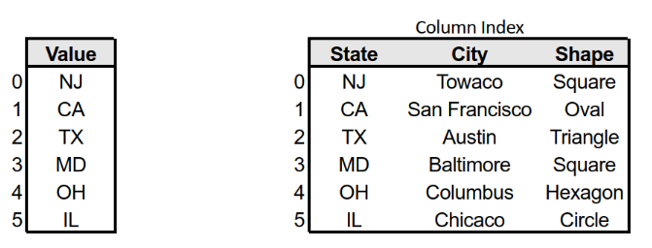

On the off chance that it appears as though the image on the left is additionally present in the image on the right, you're correct! Where a DataFrame is the whole dataset, including all lines and segments — a Series is basically a solitary section inside that DataFrame. Making these two data structures is a genuinely direct cycle in pandas as displayed underneath.

pd.DataFrame(data = [  
['NJ', 'Towaco', 'Square'],   
['CA', 'San Francisco', 'Oval'],   
['TX', 'Austin', 'Triangle'],   
['MD', 'Baltimore', 'Square'],   
['OH', 'Columbus', 'Hexagon'],   
['IL', 'Chicago', 'Circle']  
],  
 columns = ['State', 'City', 'Shape'])pd.Series(data=['NJ', 'CA', 'TX', 'MD', 'OH', 'IL'])* Side Note: Python is able to make use of "white space" so the code is easier to read - hence the new lines and spacing.

The above code will make the DataFrame and Series that we find in our picture simply above. Passing in the data is important for making DataFrames and Series with the goal that they are not unfilled. There are extra boundaries that can be passed into each of these, but for our motivations, we just need the ones passed. For more data on what these extra boundaries do, kindly investigate the documentation on DataFrames and Series.

**Some Useful Pandas Methods and Properties for Exploratory Data Analysis**

One of the primary things any great data researcher ought to do while investigating their data is to investigate it. Truly outstanding (and simplest) approaches to achieve this is to take a gander at the initial not many columns of data. By calling the .head() technique will show, of course, the initial five lines of the DataFrame and incorporate the segment headers. You can adjust the number of columns is shown bypassing a number into the enclosures, which will change the number of lines is shown.

auto.head()

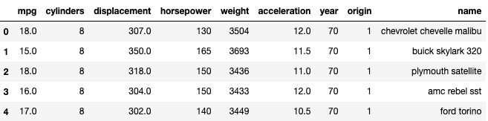

Likewise, we can likewise investigate the last couple of columns of our dataset. The .tail() strategy will, naturally, show the last five lines of our DataFrame. Like .head(), we can pass a number into our strategy to alter the number of columns are shown. We should investigate the last three lines of our DataFrame just to give you a vibe for how we can change .tail().

auto.tail(3)

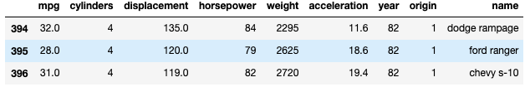

As well as taking a glance at the first or last couple of lines, it could be useful to take a glance at the number of lines and segments are in your dataset. We should investigate the .shape property.

auto.shape

Here, our dataset is displayed to have 397 lines and 9 segments. In light of our glance at the .head() and .tail() of our dataset, we saw that our dataset began at list 0 and went through file 396, affirming we have 397 absolute columns. In any case, rather than simply taking a gander at the number of lines, we might need to take a gander at the number of qualities inside our dataset that are missing. For this, we can call the .isnull() technique.

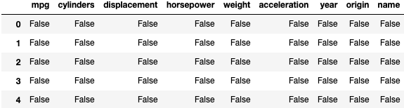

In the image above, I caught the initial 5 lines for the good of the image, however, you can accomplish this equivalent restricted arrangement of data by calling .isnull().head(). Perhaps the coolest thing about pandas and python is that it permits you to stack techniques and properties. What .isnull() does is return a Boolean expression for each worth and reveal to us whether it is missing (is invalid, or True), or regardless of whether it isn't missing (not invalid, or False).

One more perspective on invalid qualities is to stack one more technique onto our .isnull() strategy. On the off chance that we take a gander at .isnull().sum() we will see exactly the number of invalid qualities there are in every one of our segments.

auto.isnull().sum()

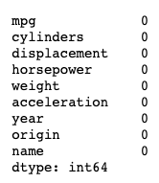

Fortunately for us, nothing, unless there are other options segments, has any invalid qualities — so we don't need to stress over dropping invalid qualities, or filling invalid qualities.

One more valuable bit of data that might be helpful to us is seeing what kind of data we have in our dataset. To do this, we can utilize the .dtypes property. This will give us a depiction of what sort of data is contained in every segment.

auto.dtypes

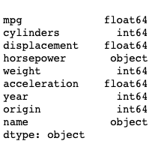

Here, we can see that we have skims (numbers with decimal spots), numbers (entire numbers), and objects (strings).

Assuming we need to take a gander at a fast rundown of the entirety of the data we've taken a gander at up until this point, one especially helpful technique that we can call is .information() which basically totals all that we've investigated up until this point!

auto.info()

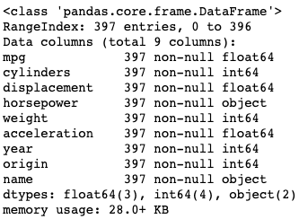

Here, we can perceive what the kind of our auto variable is (pandas.core.frame.DataFrame) — it's a DataFrame! The RangeIndex discloses to us the number of complete sections there are, from file 0 to file 396, and Data segments show us the number of all-out segments there are — for this situation we have 9 segments. Every individual segment shows us the number of sections there is the number of are invalid and the kind of that particular segment. At the base, the dtypes show us which data types we have, and the number of each. At last, the memory use shows us how much memory our DataFrame really employs.

Ideally, you've observed this to be a fast prologue to pandas, a portion of its strategies and properties, and it assists with showing you why pandas can be so valuable when taking a gander at — and examining — datasets. While this was only an exceptionally essential introduction to pandas and their techniques and properties, ideally I'll get the chance to hop into a more profound make a plunge pandas to assist with explaining a few things that were neglected.

**CHAPTER 3**

**REQUIREMENTS AND ANALYSIS**

**3.1 Problem Definition**

Although the idea helps us manage our funds for the better future, it is quite not perfect for people who are earning less as they can’t manage their funds. According to google the Average monthly salary of a person in India ranges from 29k Rs to 40k Rs per month, now considering that the person is living in City like Mumbai.

**Typical cost for basic items in Mumbai**

To examine the typical cost for basic items in Mumbai, we assessed different sorts of consumption that a family needs to bear to live in the city. The beneath assessment is based on cost of purchasing/leasing a home, driving, cost of eating out, power charge, web costs, cost of tutoring, vehicle fuel and absolute minimum expense of purchasing leafy foods.

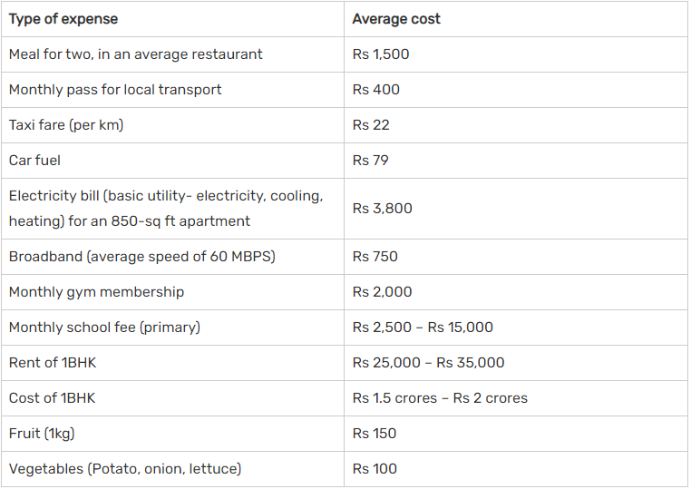

Now that we’ve seen the above expenses we can accurately see where the problem arises.

Here Expenses are higher than the Income, and when that happens a person can hardly save a dime. To survive through all this and later have to save up for investments it will be much harder and he/she might give up on savings.

As per Mercer's 2021 Cost of Living Survey, Mumbai stays the most costly city for expats in India and among the best 20 in Asia. Be that as it may, Mumbai slipped to the 78th position, this year. After Mumbai, which dropped from 60th to 78th, New Delhi dropped 16 places this year and Chennai was down 15 spots. Bengaluru acquired one spot while Kolkata acquired four spots.

**Cost of living in Mumbai for bachelors**

**Normal lease and purchasing cost:** If you are an unhitched male, you can select co-living spaces in Mumbai, which would cost you Rs 10,000-20,000 for every bed, contingent on the offices accessible and area. This could go up to Rs 30,000 every month in case you are selecting a dinner office.

**Household Cost:** Since a large portion of the offices and conveniences are remembered for co-living facilities, you won't need to pay extra charges, like support, power or Wi-Fi bills. Be that as it may, in case you are deciding on a free living alternative, you might need to lay out Rs 5,000 every month extra, to meet the extra costs.

**Transportation cost:** Mumbai is very much associated by means of the neighborhood train organization and BEST transports. A month to month pass would differ between Rs 300 and Rs 700, as indicated by the solace you look for (AC/Non-AC) and the distance you travel every day.

**Lifestyle cost:** Depending upon how as often as possible you go out, the way of life cost might change in like manner. A film ticket costs Rs 300 for every individual while eating out in a spending lodging might cost Rs 300 – Rs 500 for each individual.

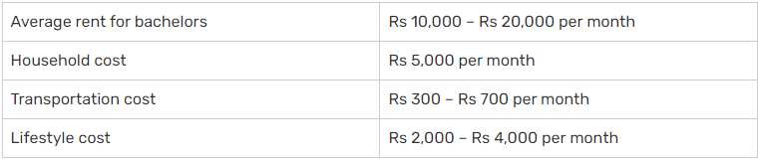

**Cost of living in Mumbai for a family with children**

Ordinary rent and buying cost: If you need to rent a 2BHK condominium in Mumbai, to some degree away from the midtown region or in the suburbs, you need to spend around Rs 40,000-50,000 consistently. Thane and Navi Mumbai are two distant country spaces of Mumbai where property costs are moderate anyway you would have to spend more on driving. Accepting you need to buy a 2BHK apartment suite in Mumbai in the western country regions, you need to spread out basically Rs 2.5 crores.

Family cost: A family which consolidates a working couple and a young person, will have costs like food, clothing, school costs, housekeeper pay, upkeep charges and alternate lifestyle related utilization. This could move between Rs 25,000 and Rs 30,000, dependent upon various parts. For childcare organizations, you would have to contribute on full-energy childcare or overseers, if your child is in pre-school. This may cost you around Rs 5,000-10,000 consistently, dependent upon the idea of the organizations. An overall grade school will cost you around Rs 1.5 lakhs – Rs 4 lakhs every year.

Transportation cost: If you travel in a private vehicle, you might need to spend on vehicle fuel which could be wherever between Rs 5,000 and Rs 6,000 consistently, dependent upon the distance you travel. You ought to spend on halting charges as well, if your office or society doesn't have free halting.

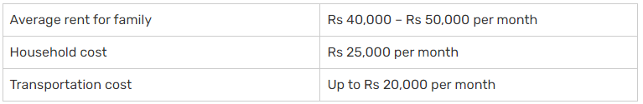

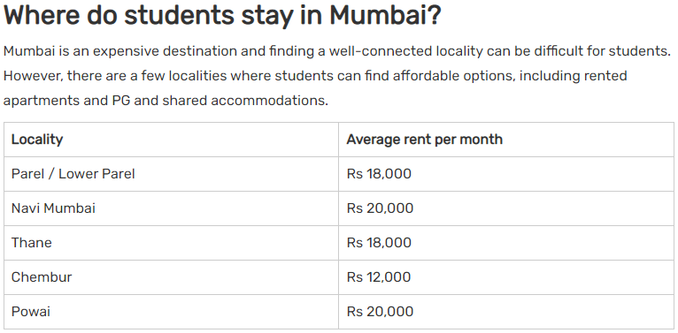

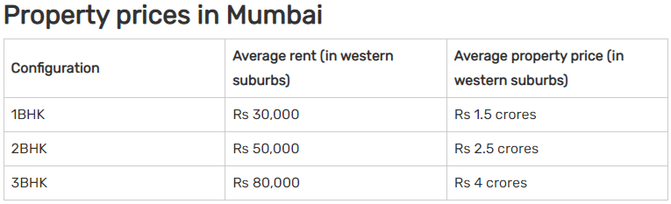

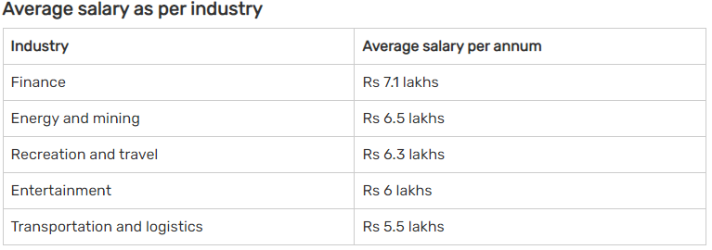

**Healthcare in Mumbai**

In an as of late delivered report, named 'Territory of Healthcare in India' by Housing.com, the Mumbai Metropolitan stood fourth with boundaries like the quantity of beds, air quality and liveability pulling its general score down. The following are the discoveries shared by Numbeo.com on the condition of medical care in Mumbai.

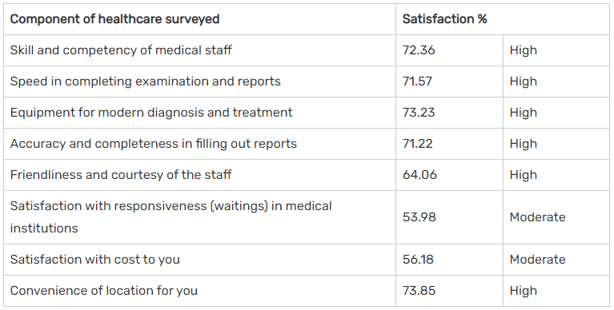

**3.2 Requirements Specification**

Considering the above income to expenses we can say that the minimum requirement specification for a person who’s living in Mumbai is to earn at least 60,000 Rs to 80,000Rs and if they earn more than that it would completely solve their expense problems as they can save enough money for the investments which will end up giving them higher returns in the near future. But there’s a catch here, you can’t just earn more money just by doing a degree, you should either have a post graduate degree or other skills which industry demands and to build up those skills you’ve to study out of syllabus while doing college. One cannot spend time improving themselves while they are doing the job because they are under huge pressure by their seniors to complete the task, in such condition they might not be able to concentrate on their goal and can never improve their skills in the area they were trying to work. Best time to improve and add skills up your sleeves is when you’re in college as you have enough time to study.

Although you might study and add up your skills you sometimes won’t be considered as others might have the experience you don’t have, to eliminate this issue you can do internships while you’re in college and you can even inform the college to compensate with you on attendance of college. Sometimes internships are unpaid but they are totally worth the effort because they are going to give the experience you might not even get when you are doing the job.

These internships might help you crack your upcoming interviews with ease and with this you might end up with a better paying job helping you keep your life on track. All these things must be planned before you start job, as after that you might not get the chance to study and improve yourself.

**3.3 Planning and Scheduling**

Now, that you are past the requirement specification you might have enough idea on how things will work here onwards.

Investment is not everyone’s cup of tea as they don’t know how much returns they will receive and if there are higher returns then how safe is it to invest your money in that field and let’s consider if you are investing in Share market then do you even know how will that company’s share will do in long run.

This project will help you see how to manage your funds and analyse the expenses, it can give you the brief idea on how much returns you will receive at the end if your investment gives you 5%, 10%, 15%, 20% etc…………. returns in the long run. You’ve to study market and how things work as it’s always safe to handle your funds rather than giving it to some agent who will invest them for you because most of the time they charge you for this activity. Also if you study and invest your funds will always be in front of you and don’t have to worry about it all the time.

**3.4 Software and Hardware Requirements**

Software and hardware requirements for this project are really unusually low.

**Software Requirements:-**

1. Microsoft Office (EXCEL)
2. Python 3.8 or higher version
3. Jupyter Notebook

*There might be some changes in Software requirements in the near future as we update our work and overtime you may need other softwares/sub requirements.*

**Dependencies:-**

1. Numpy
2. pandas
3. Matplotlib
4. seaborn
5. datetime
6. time

*The dependencies might also change as we update work and you may need to install new dependencies.*

**How to install Python Dependencies:**

You need to open command prompt as Administrator like shown below

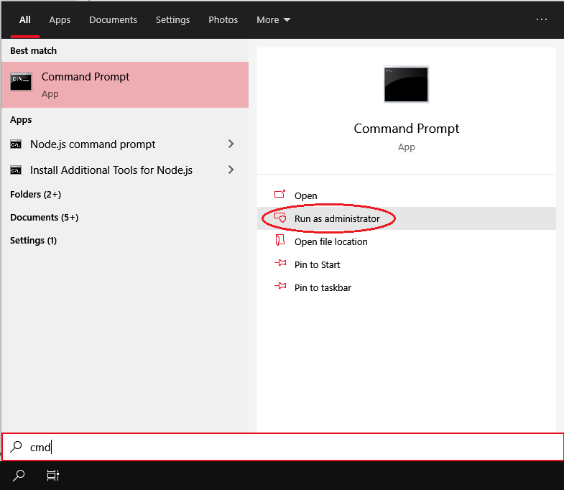

After opening it with Administrator privileges you should write the following commands.

1. **pip install numpy**

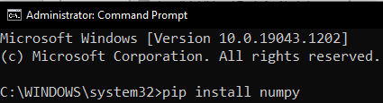

1. **pip install pandas**



1. **pip install matplotlib**



1. **pip install seaborn**



1. **pip install datetime**



1. **pip install time**



*Sometimes some of the dependencies are installed by default in Jupyter Notebook, at that time you might get this message when you execute the above commands.*



Download Links Software Requirements are as follows:

1. [**https://www.microsoft.com/en-in/download/office.aspx**](https://www.microsoft.com/en-in/download/office.aspx)
2. [**https://www.python.org/downloads/**](https://www.python.org/downloads/)
3. [**https://www.anaconda.com/products/individual**](https://www.anaconda.com/products/individual)

The above Information provided is software Requirement for our Project.

* 1. **Hardware Requirements:**

1. **For Python 3.8**

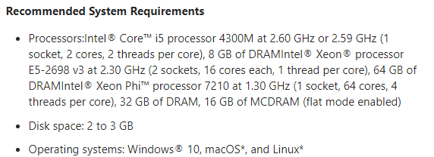

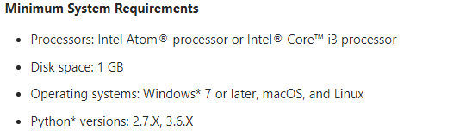

1. **For Anaconda**

**Hardware requirements**

CPU: 2 x 64-bit 2.8 GHz 8.00 GT/s CPUs

RAM: 32 GB (or 16 GB of 1600 MHz DDR3 RAM)

Storage: 300 GB. (600 GB for air-gapped deployments.) Additional space recommended if the repository will be used to store packages built by the customer. With an empty repository, a base install requires 2 GB.

Internet access to download the files from Anaconda.org or a USB drive containing all of the files you need with alternate instructions for air gapped installations.

**Other Requirements**

License file provided to you by Anaconda at the time of purchase

Installation tokens for binstar and anaconda-server channels provided by Anaconda at the time of purchase. Not applicable for air gapped installs.

Optional: Your Anaconda.org account credentials. Not applicable for air gapped installs.

1. **For Microsoft Office**

**Computer and processor** 1.6 GHz or faster, 2-core.

Professional Plus: 2.0 GHz or greater recommended for Skype for Business.

**Memory** 4 GB RAM; 2 GB RAM (32-bit)

**Hard disk** 4 GB of available disk space

**Display** 1280 x 768 screen resolution

**Graphics** Graphics hardware acceleration requires DirectX 9 or later, with WDDM 2.0 or higher for Windows 10 (or WDDM 1.3 or higher for Windows 10 Fall Creators Update).

**Professional Plus** Skype for Business requires DirectX 9 or later, 128 MB graphics memory, and 32 bits per pixel capable format.

**Operating System** Windows 10, Windows Server 2019

**Browser** The current version of Microsoft Edge, Internet Explorer, Chrome, or Firefox.

**.NET version** Some features may require .NET 3.5 or 4.6 and higher to also be installed.

**Other**:

Internet functionality requires an Internet connection. Fees may apply.

A touch-enabled device is required to use any multi-touch functionality. But, all features and functionality are always available by using a keyboard, mouse, or other standard or accessible input device. Touch features are optimized for use with Windows 10.

Product functionality and graphics may vary based on your computer configuration. Some features may require additional or advanced hardware or server connectivity.

Cloud file management features require OneDrive, OneDrive for Business, or SharePoint.

Microsoft account or Microsoft organizational account that is required for license assignment.

Professional Plus: Skype for Business requires a standard laptop camera or USB 2.0 video camera, a microphone, and an audio output device in order to use its full range of calling and meeting features. Microsoft recommends that you use certified devices for the best experiences. For exact client video requirements.

**Outlook:**

Some search functionality requires Windows Search.

Certain advanced functionality may require connectivity to a supported version of Microsoft Exchange Server (or Exchange Online) or Microsoft SharePoint Server (or SharePoint Online). See the Microsoft Support Lifecycle Policy  site for supported versions of Exchange Server and SharePoint Server.

Integration with Skype for Business or Microsoft Teams requires connectivity to a supported version of Skype for Business or Microsoft Teams. See the Microsoft Support Lifecycle Policy  site for supported versions of Skype for Business and Microsoft Teams.

LinkedIn support requires a LinkedIn account.

Speech recognition functionality requires a microphone.

Read-aloud functionality requires an audio output device.

Rights Management features require access to either a cloud deployment of Microsoft Rights Management (Azure Rights Management) or an on-premises deployment (Active Directory Rights Management Services).

Dynamic calendars require server connectivity.

**Chapter 4**

**Note:- Since the application is in developing stage there can be changes taking place in the application which will be released in near future.**

Here the Idea is to create an Client side application for better usability while the web application is more secure as it will be handled on servers which will be protected by multiple encryptions for data.

Here even if the user machine’s security is compromised there will be no issue with their data as it won’t get leaked in any possible way unless the Encryption Key is known by the hacker. This server will be hosted on AWS

* 1. **About AWS: (Amazon Web Services)**

Utilizing AWS, we will acquire the control and certainty we need to safely maintain our business with the most adaptable and secure distributed computing climate accessible today. As an AWS client, we will profit from AWS server farms and an organization architected to ensure your data, personalities, applications, and gadgets. With AWS, you can further develop client capacity to meet center security and consistence prerequisites, like information area, assurance, and privacy with our exhaustive administrations and components.

AWS permits us to mechanize manual security assignments so we can move your concentration to scaling and enhancing our business. Additionally, we pay just for the administrations that we use. All clients advantage from AWS being the main business cloud that has had its administration contributions and related inventory network verified and acknowledged as secure enough for highly confidential jobs.

* + 1. **Benefits:**

**Scale Securely with Superior Visibility and Control**

With AWS, you control where your information is put away, who can get to it, and what assets your association is burning-through out of nowhere. Fine-grain personality and access controls joined with consistent observing for close to ongoing security data guarantees that the right assets have the right access consistently, any place your data is put away.

**Mechanize and Reduce Risk with Deeply Integrated Services**

Mechanizing security assignments on AWS empowers you to be safer by lessening human arrangement blunders and giving your group more opportunity to zero in on other work basic to your business. Select from a wide assortment of profoundly incorporated arrangements that can be consolidated to robotize assignments in original ways, making it simpler for your security group to work intimately with engineer and tasks groups to make and send code quicker and all the more safely.

**Work with the Highest Standards for Privacy and Data Security**

AWS is cautious with regards to your protection. With AWS you can expand on the most dependable worldwide foundation, realizing you forever own your information, including the capacity to encode it, move it, and oversee maintenance. All information streaming across the AWS worldwide organization that interconnects our datacenters and districts is naturally scrambled at the actual layer before it leaves our got offices. Extra encryption layers exist also; for instance, all VPC cross-locale looking traffic, and client or administration to-support TLS associations.

**Biggest Ecosystem of Security Partners and Solutions**

Broaden the advantages of AWS by utilizing security technology and counseling administrations from recognizable arrangement providers you definitely know and trust. We have painstakingly chosen providers with profound mastery and demonstrated achievement getting each phase of cloud reception, from introductory movement through continuous everyday administration.

**Acquire the Most Comprehensive Security and Compliance Controls**

To help your consistence endeavors, AWS routinely accomplishes outsider approval for huge number of worldwide consistence necessities that we consistently screen to assist you with satisfying security and consistence guidelines for finance, retail, medical care, government, and then some.

**4.2 Vital Security**

AWS is intended to assist you with building secure, high-performing, tough, and proficient foundation for your applications. Elite security specialists who screen our foundation likewise fabricate and keep up with our expansive determination of inventive security administrations, which can assist you with improving on gathering your own security and administrative prerequisites. Our security administrations and arrangements are centered around conveying the accompanying key advantages basic to assisting you with carrying out your association's ideal security pose:

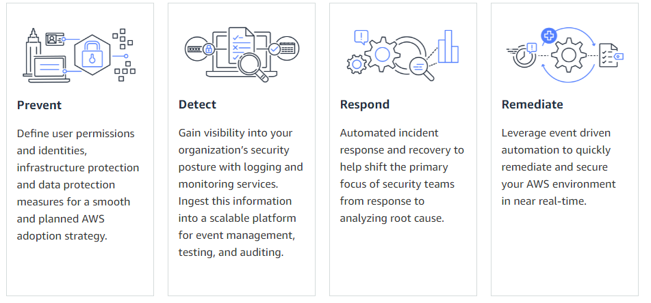

**4.3 Basic Modules**

* **Registration:**

In this module the user first have to register themselves with our system. The registration will take place only when the user provides all the necessary information without dodging. They must provide their Citizen ID, PAN, Photo ID any many more.

* **Login:**

Here once a person registers himself successfully they can now enter Login page and fill up the credentials for login. Login will take place once the person enters the correct password and the system can identify if the account is logging in from their regular location or location far away from the regular one and send them notification about it.

* **Confirmation via 2FA:**

Google 2FA can be used and it’s totally up to user to add 2FA to their account or not. It’s usually preferred to use 2FA as recently account hacking has become a common problem among people using internet these days.

* **Control Panel:**

In this Panel a person can start tracking their progress as well as stop tracking based on their preference. Person can see their Investments status, Amount left, Track Live Progress toggle, Add new Investments, Manage Account, Income.

* **View Investments:**

This tab will show you how much your investments are and if you click on more it will tell you specifically where all of your money has been invested by you. This tab

* **Support:**

In this section you will find all the contact information for customer support or discussion forums of the official website.

* **Reviews:**

Here you can find the reviews by the current users of our website/application. You can also upload your reviews and what all things you expect from the application.

**4.4 GUI for Website: [Graphical User Interface]**

The GUI of the website has been specifically designed user friendly and there are no complex terms for a beginner.

1] Once the user enters our webpage this is what they will first experience. Added vibrant colours for making it look even friendlier.

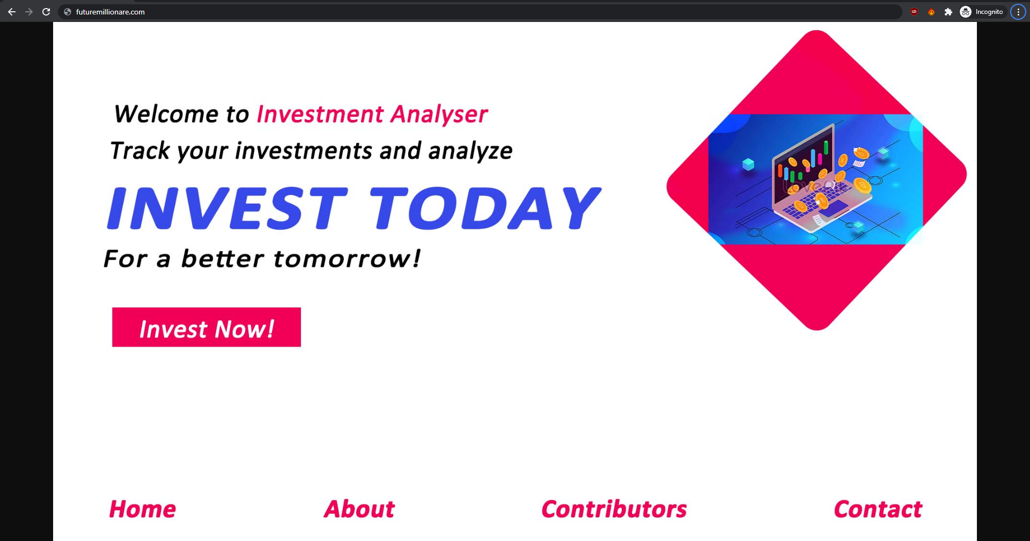

2] When person clicks on Invest now they will be redirected to the login page.

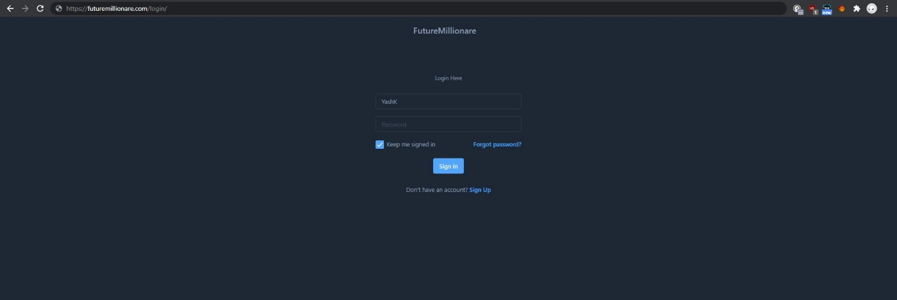

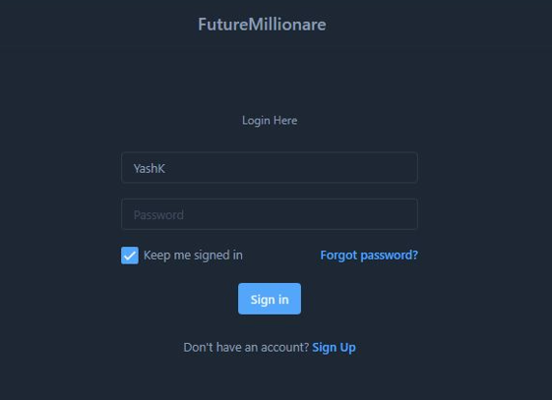

3] If the person don’t already have an account, they can sign up by clicking on it.

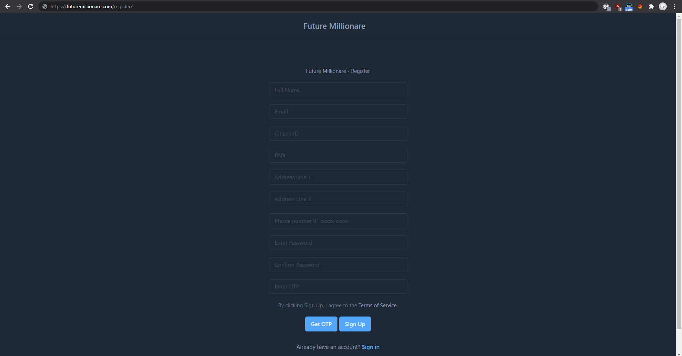

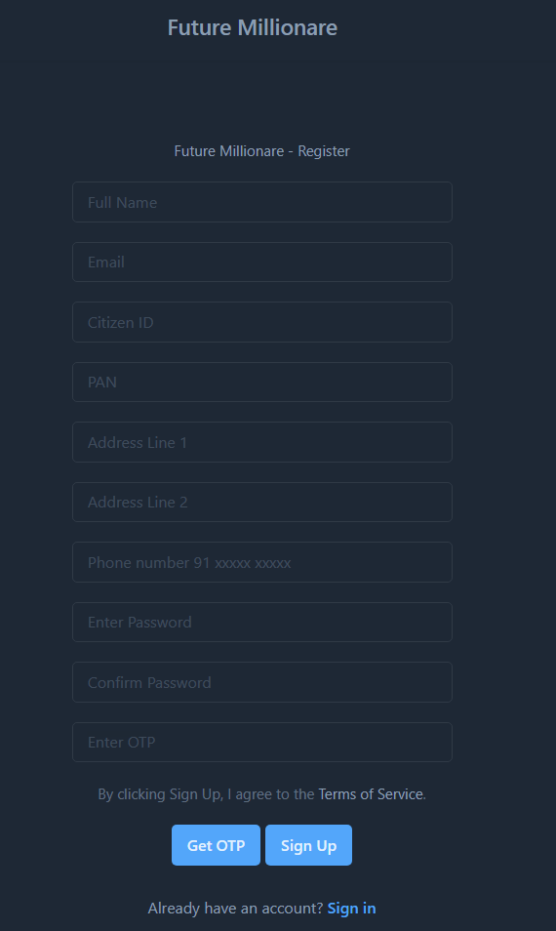

4] Once they successfully login, they will now be able to see the Control Panel.

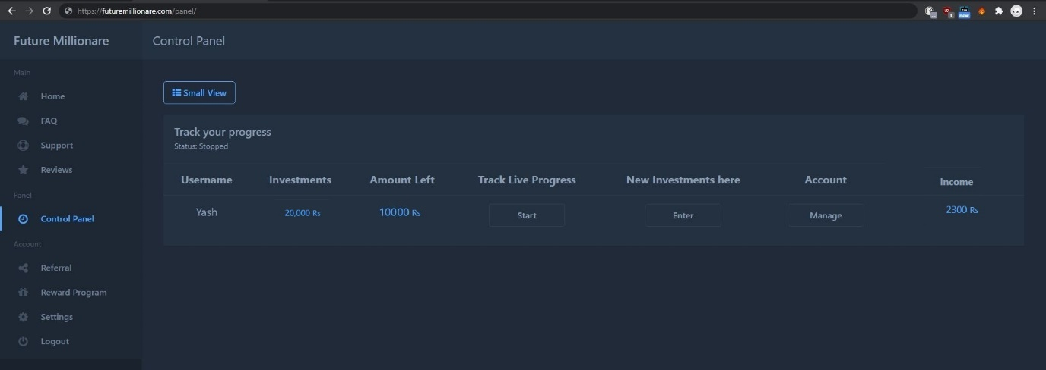

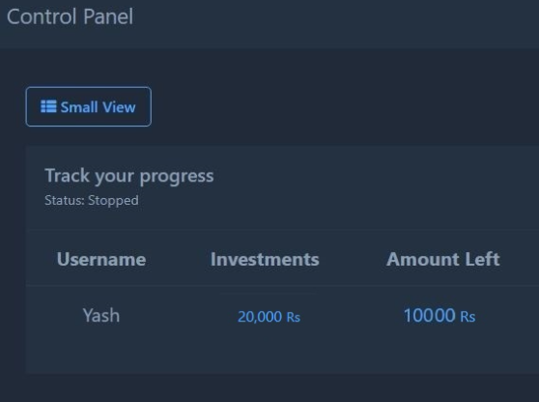 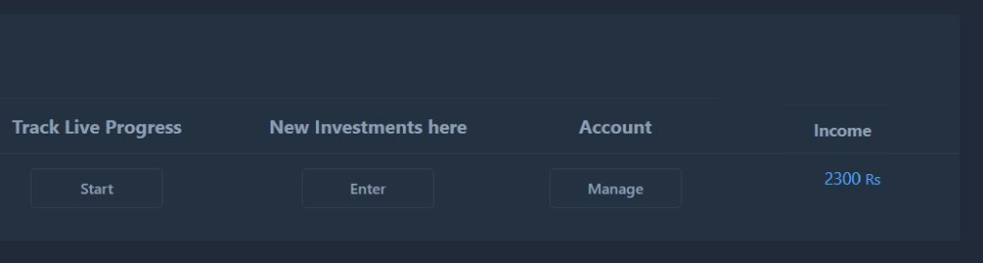

5] On the Support Tab you will be able to get information about creator and way to contact the team.

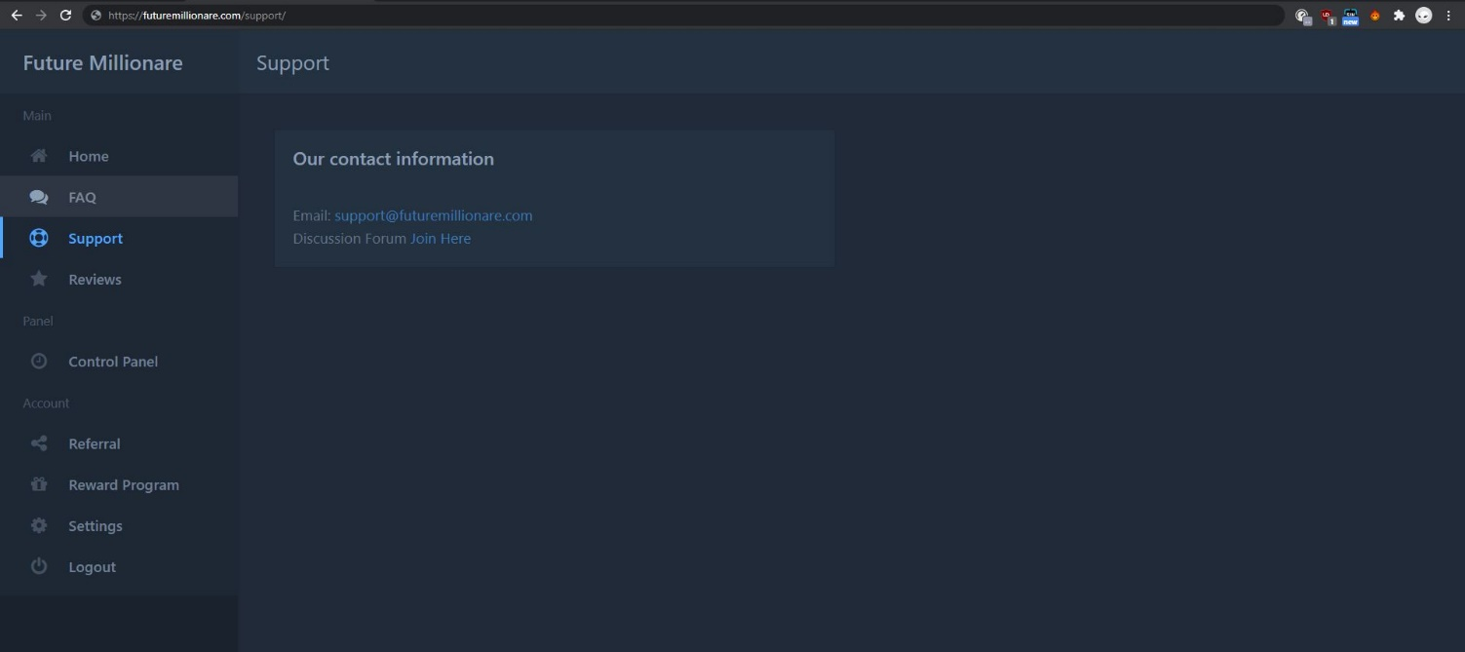



6] Refer FAQ for Frequently asked questions:

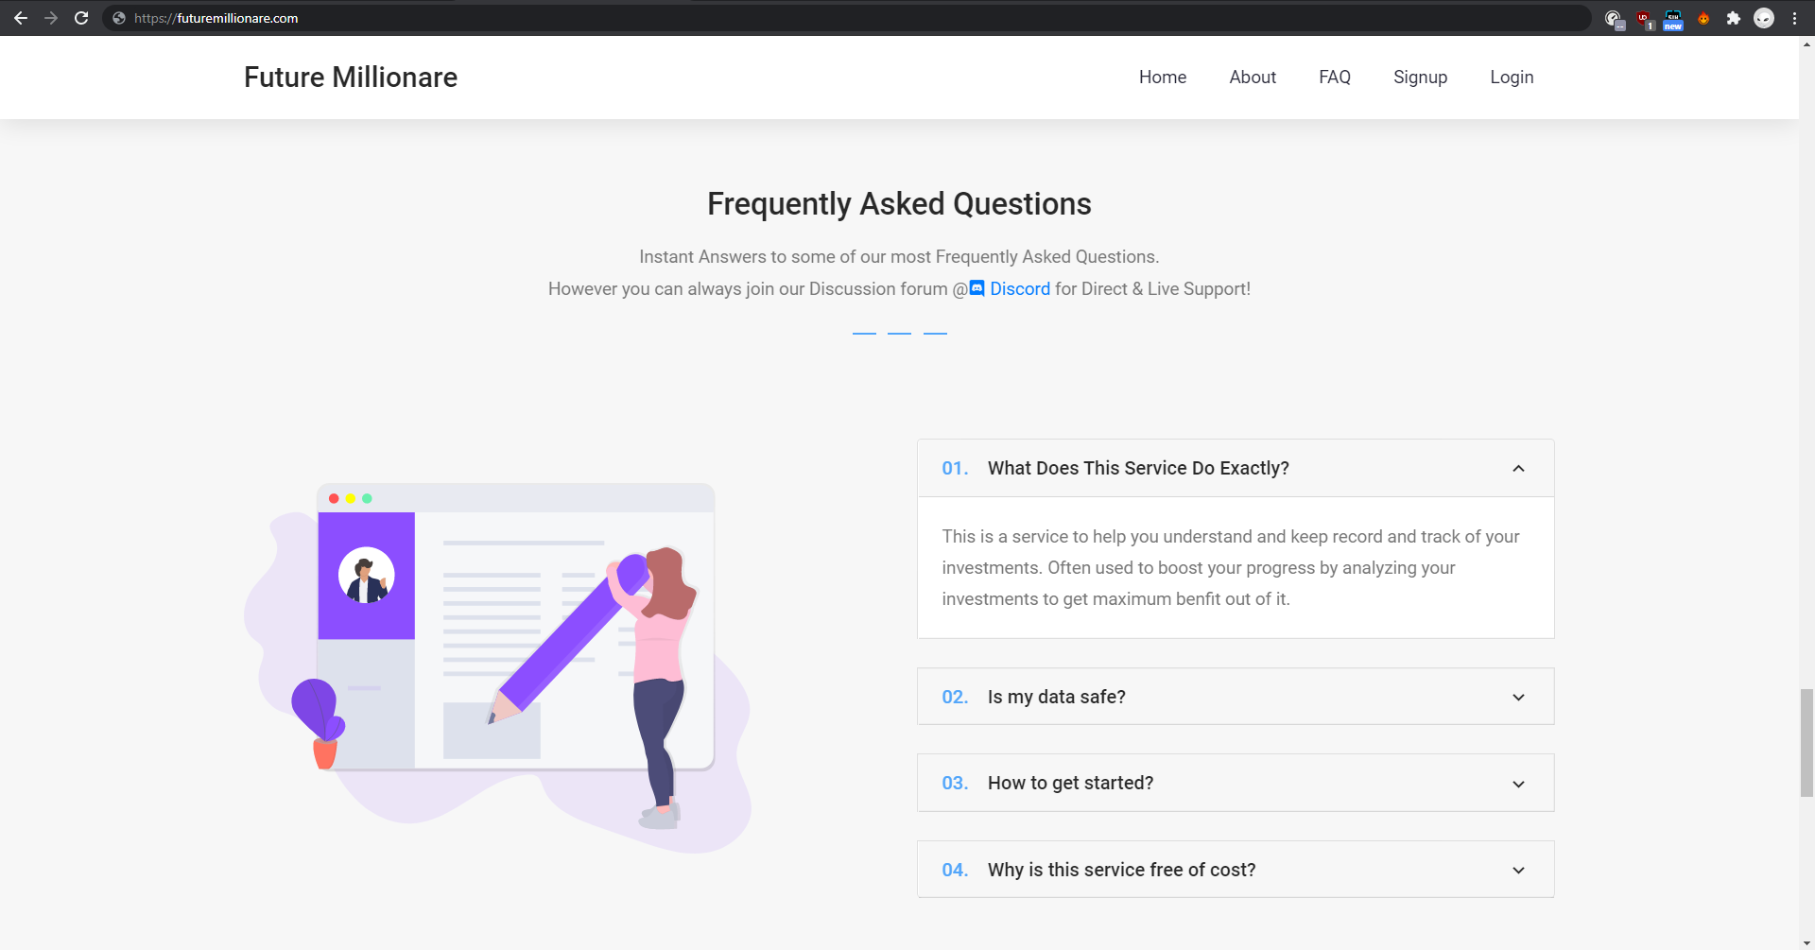 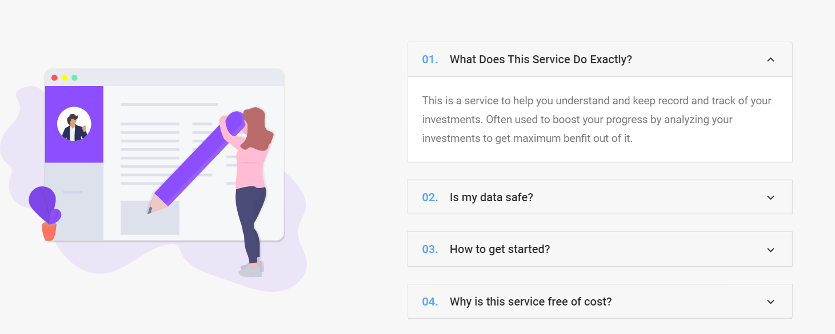

7] Reviews tab will show you all the reviews which are given to us:

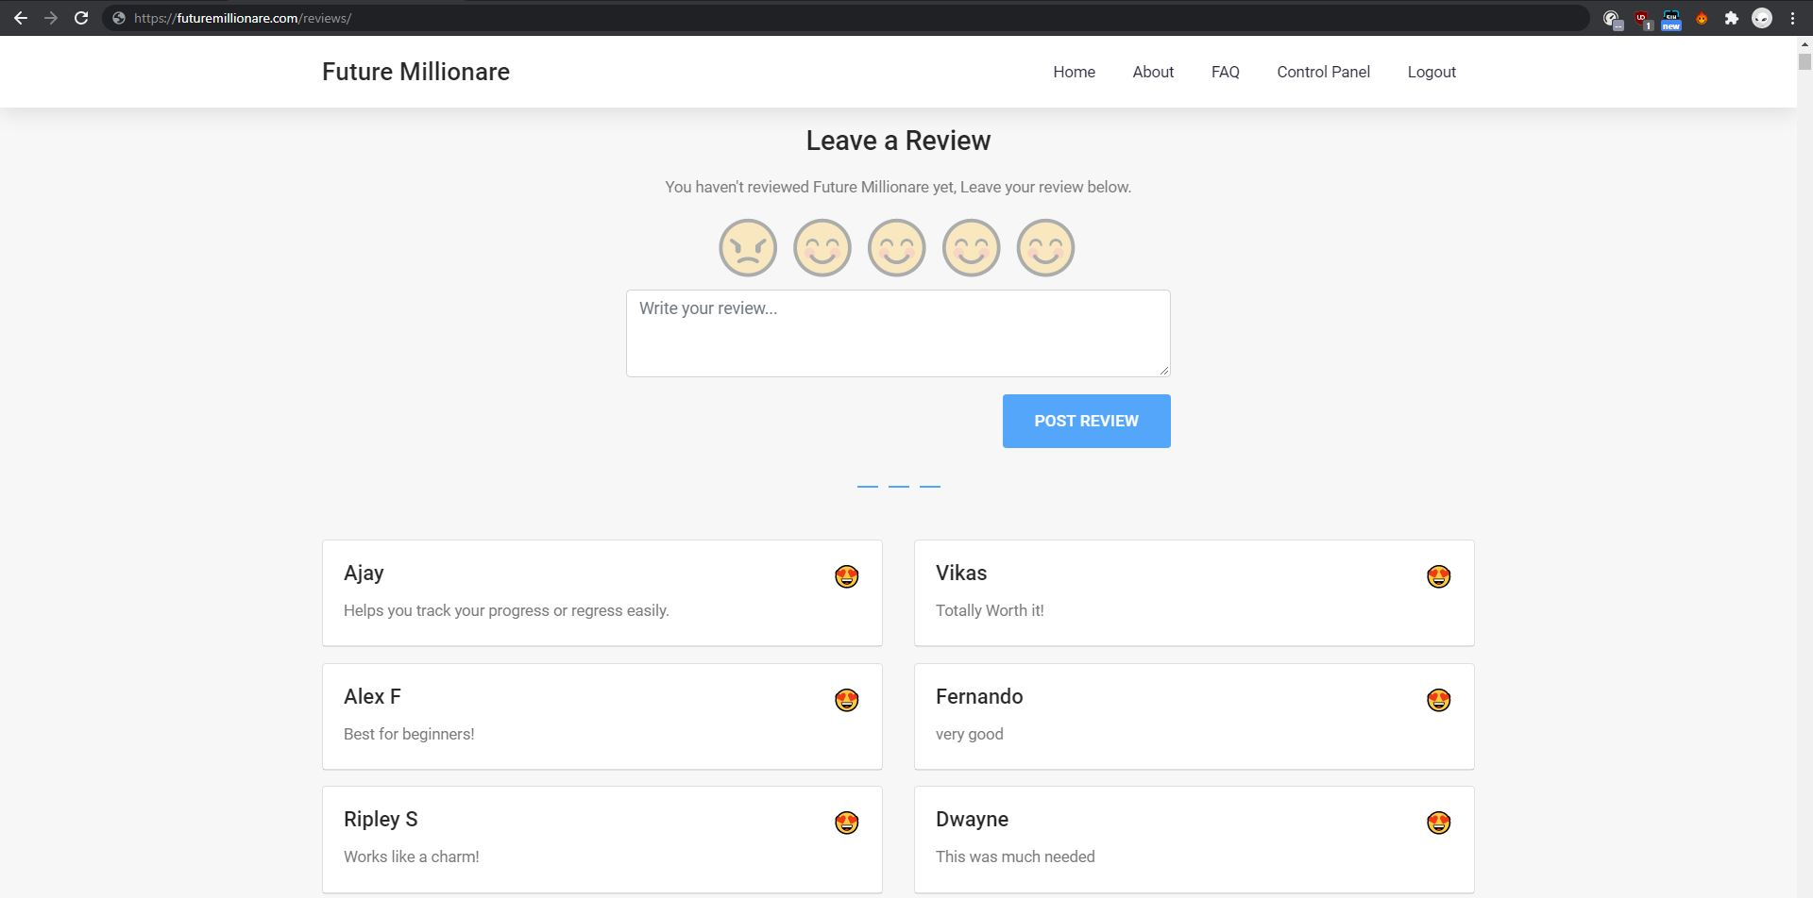

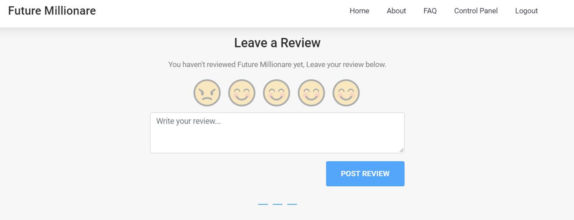

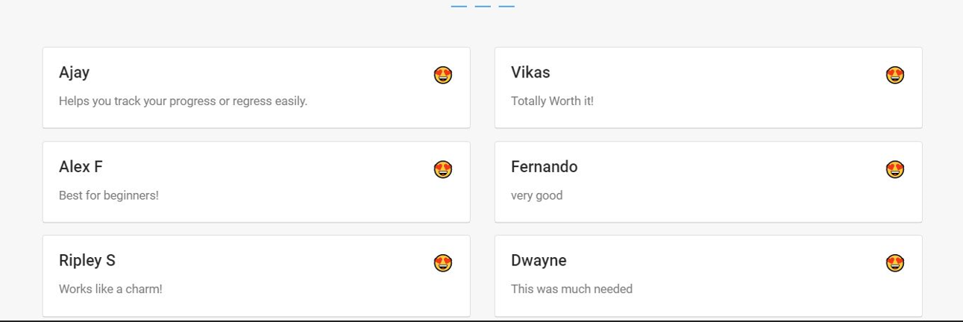

**4.5 Working of Application:**

For using the application, the person must provide application with the data of their purchases. This data will include Name of the Share (company name), Date of Purchase, Quantity.

1] Once the user provides us with sufficient data we will import this data to our program with this code.

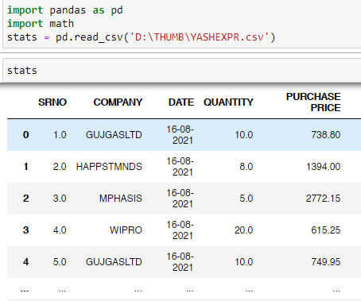

2] Once we import this information we will sort only company names.

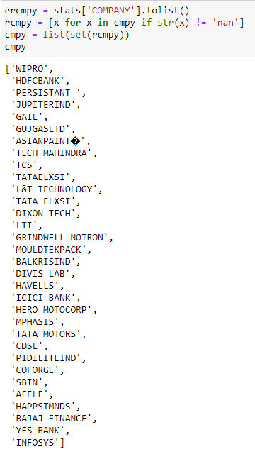

The above code will filter the record which are repeated and records with no value will be eliminated.

3] There are multiple ways of importing data from Yahoo Finance.

* 1st Method

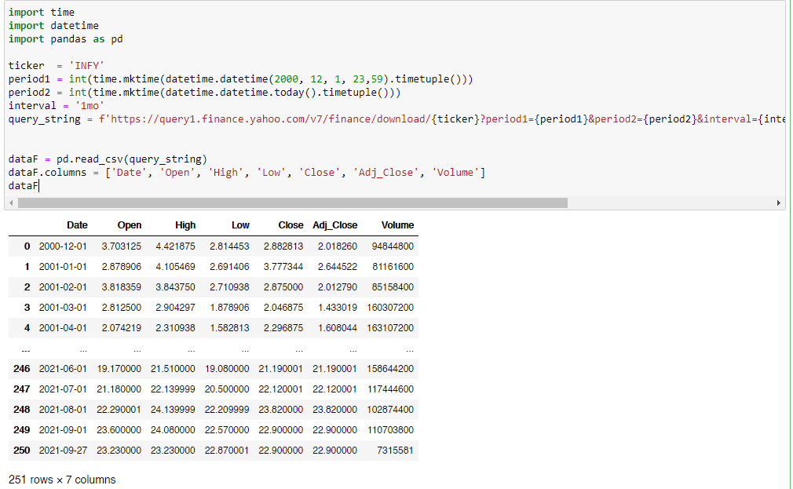

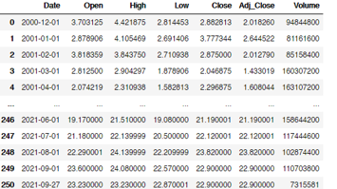

* 2nd Method

[In this method we might’ve to write down the name of each share for now but later we can solve this issue]

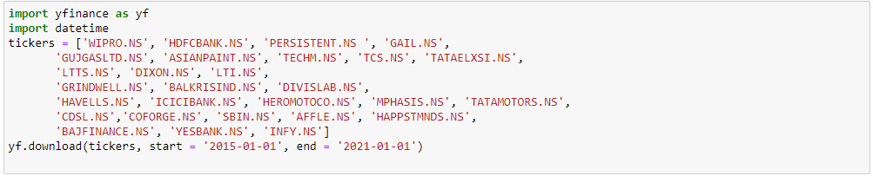

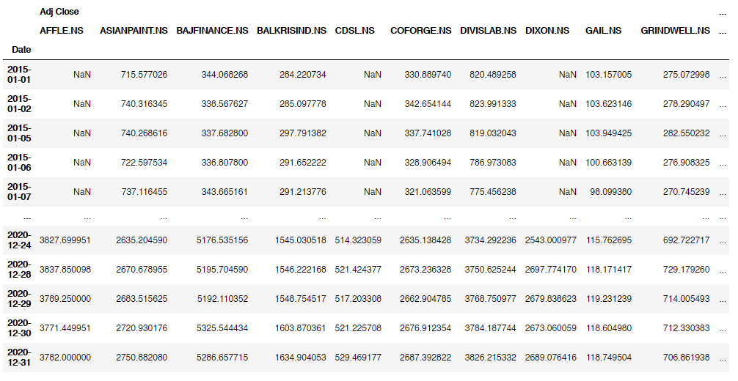

4] Now we can calculate the Profit / loss by subtracting the amount of current share price by the amount we purchased the share.

So we’ve to call the purchase price from the data provided by the user and then subtract it from the data which we’ve imported from yahoo finance.

Once we get the profit or loss we can calculate the percentage of Profit or Loss with the help of the formula

(profit or loss / Purchase Price) multiplied by 100.

This way we can create a meaningful data which will help us analyse which share is performing better and where should we invest in future.

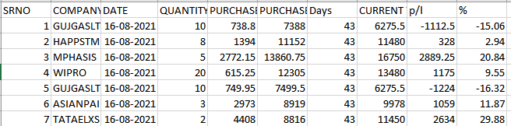

From the derived data we can see the number of days we had shares, current price of share, profit or loss calculated, and % of profit or loss which has occurred.

Considering the above data we can see that MPHASIS, TATAELXS, ASIANPAINT has given us a good return by making 20%, 29% and 11.87% increase in our investments.

Whereas worst performing share are GUJRATGASLTD.

There are few which are not giving profit but steadily growing like WIPRO, HAPPIESTMINDS etc.

This way you can decide which company you should spend more on to minimize the losses and increase your profits.

Below Pictures will give you a brief idea on how each set of code will work.



This command will help you import the prices of shares to your local machine from yahoo server.



If you open this csv file you will see the following:

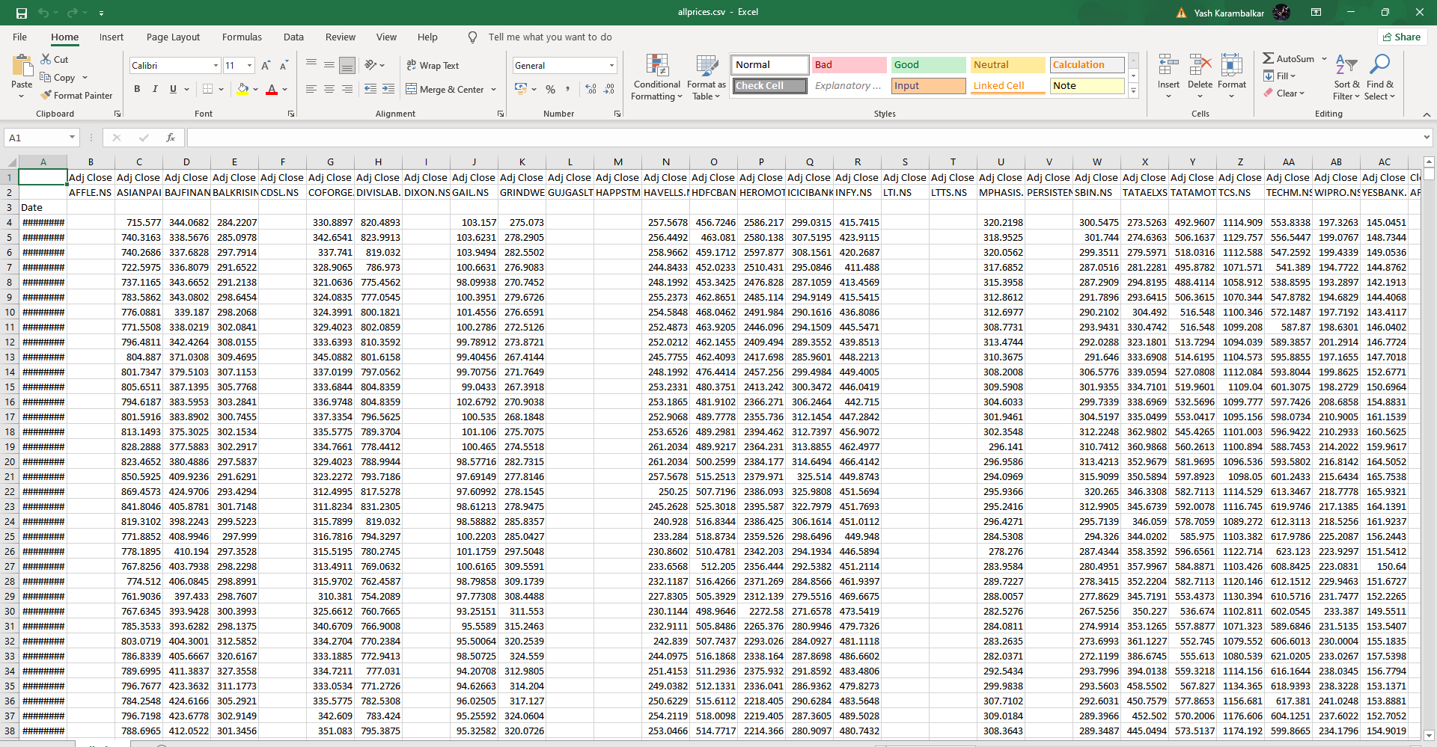

This data must be modified, you’ve to remove .NS from All the share’s name and remove the first row’s column names

From this:

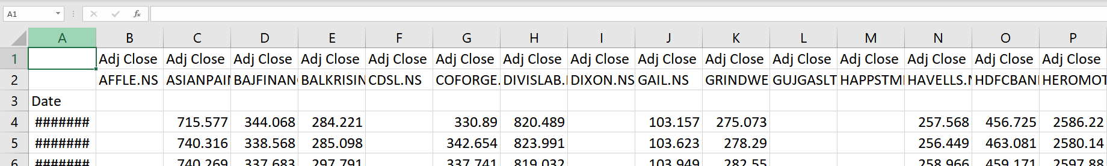

To this:

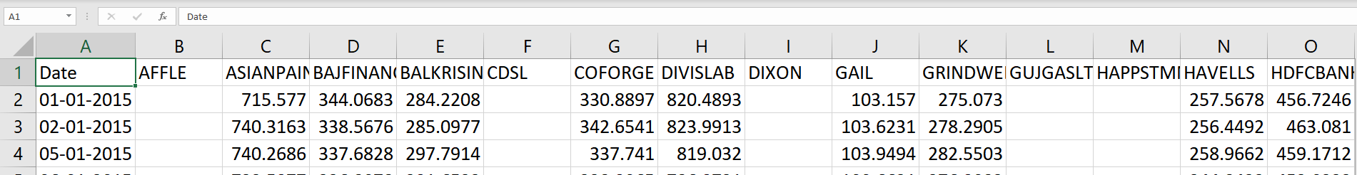

Once you’ve done it change the file name to something different and import it again as Python cannot directly work with the data imported as it needs to be filtered.

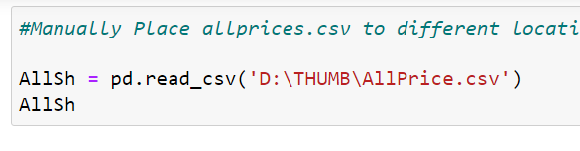

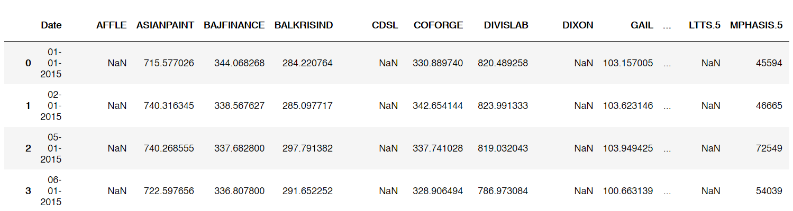

Now this is the imported data from website which we filtered and now it’s all ready to be used for our further calculations.

Since the project is ongoing stage we will just show you how we will calculate but first we need to prepare. So we will take here only 1 Share, let’s say “WIPRO”.

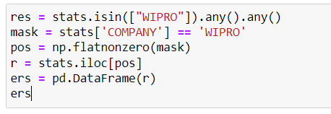

This code will help us filter WIPRO from all the user data which they provided.

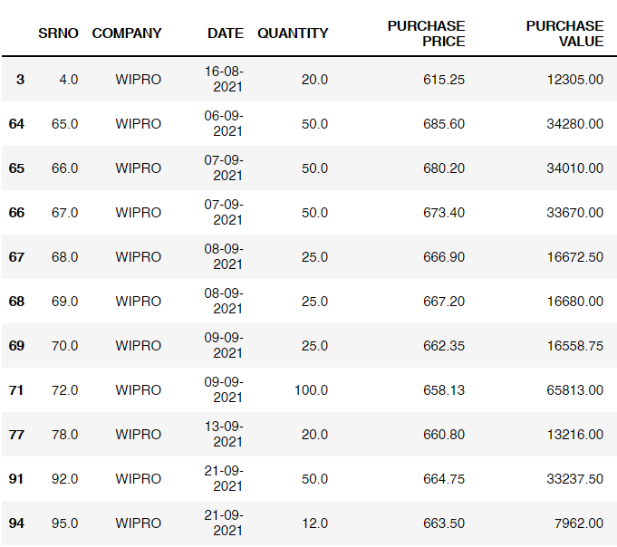

Now that we’ve the user data which we require we will now find the current price of share using the following code:

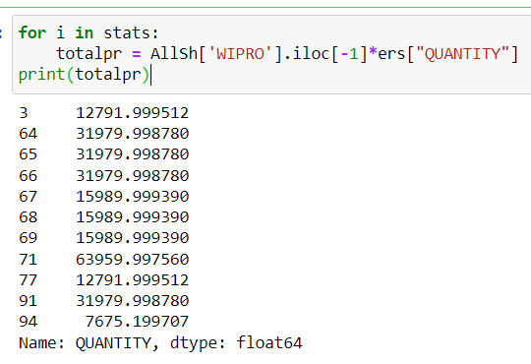

Once we’ve to current price of our share we can easily calculate the Profit/Loss by using the formula: Current Price – Purchase Price

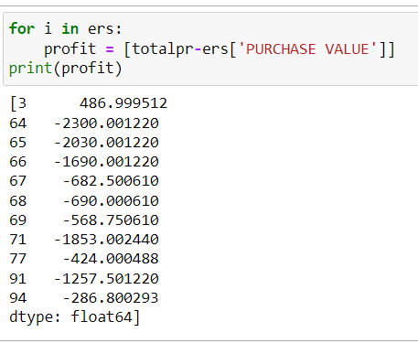

Similarly if required we can calculate the profit percentage as well.

Now that we know how each set of code is going to work we’ve to implement the loops in order to get profit / loss for each share and that will help us keep track on our investments.

Now considering you’ve got a good package from a company who pays you 1L per month. You can manage your funds by using our EXCEL application which is pre-embedded by the formula for the calculations.

* Consider you’re earning 1Lac per month then the first step is to keep aside Rs. 20000 or 10% of your income aside. **[For Basic Needs]**
* Now use 30% of your income for your wants such as Car Loan EMI, TV, Computer, Etc. **[For wants(entertainment)]**
* Remaining amount, you can utilise for investments.

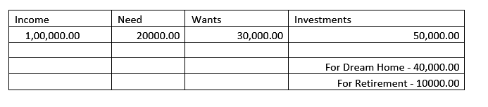

Question which may arise:

**Question:** Why we have to invest for a Dream Home or Anything as we can have our same dream come true by taking loan from banks.

**Ans:** If we take home of Rs. 1 Cr. today and suppose we take loan of Rs. 90 lakhs for 20 years at the rate of 6.85% (rate is as per SBI)

Then you will pay Rs 1.65 crore in 20 years with EMI of Rs. 68969 and the same property will become mortgage free after 20 years.

Instead, you can take same house on rent at Rs. 15,000 p.m. and invest 40000 for Investment in MF you will get:

|  |  |
| --- | --- |
| Current Age | 25 |
| Retirement Age | 50 |
| Monthly Contributions | 40,000 |
| Yearly increase in contribution | 1% |
| Inflation | 7% |

|  |  |  |  |  |
| --- | --- | --- | --- | --- |
| **If you make this return** | **Your bank will show this amount** | **But, adjusted for inflation this amount will be equal to?** | **In other words, at the end of your retirement age, you will have** | |
| 5% - FD returns | 2,62,37,338 | 1,07,99,081 | **1.1** | Crores (in today's money) to spend |
| 10% - Gold returns | 5,71,78,119 | 1,97,99,976 | **2.0** | Crores (in today's money) to spend |
| 15% - Equity returns | 13,73,83,574 | 4,10,23,514 | **4.1** | Crores (in today's money) to spend |
| 20% - High risk equity returns | 35,49,10,711 | 9,45,09,502 | **9.5** | Crores (in today's money) to spend |
| 25% - very hard to get | 96,46,24,712 | 23,62,99,512 | **24** | Crores (in today's money) to spend |
| 30% - extremely risky | 2,71,46,89,332 | 62,64,43,456 | **63** | Crores (in today's money) to spend |
| 35% - almost impossible | 7,82,45,30,895 | 1,72,93,09,480 | **173** | Crores (in today's money) to spend |
| 40% - forget it :) | 22,92,90,38,384 | 4,90,81,91,608 | **491** | Crores (in today's money) to spend |

Now Consider if you invest instead of taking loan, you may earn more than 1Cr (least) upto 15-20Cr (Most) after 20 Years of your investments. If you had taken loan you might end up paying EMI’s for 20 years which means you may not be able to change your job for next 20 years or up until you get higher paying JOB which you enjoy.

Not just that if you get the JOB away from your home you will face travelling issues and you will be stuck in the same environment and can never enjoy living out in different environment which can even make your life little miserable.k

**4.6 Now there are exceptions:**

If you’re from a rich background and have enough money to buy House worth 1Cr without taking any loan then you should go for it as the value of House will increase over the period of time and you will get higher returns. This is also a kind of investment which will give you good returns.

Also you don’t really have to stay in that apartment, you can just rent it to others and it will not only act as an investment property but also give you income on monthly basis.

This was brief explanation on how this project will work. This is to improvise the old thinking of purchasing an apartment by taking loan, instead if you invest you are going to make a lot more and enjoy your life while not just staying in single environment which kind of makes life depressing. Even after the retirement you’re going to get the benefits of your investments because now not only you’ve a great apartment but also you’ll be getting an money from bank in a form of interest which can act as an income. This income can vary based on your contribution.

**References**

1. G Akerlof

The Market for Lemons: Qualitative Uncertainty and the Market Mechanism

Quarterly Journal of Economics, volume 84, p. 288 - 300

Posted: 1970

1. H Levy, T Post

Investments

Posted: 2005

1. J C Van Horne, Wachowicz J

Fundamentals of Financial Management

Posted: 2005

1. Central Bank of Bosnia and Herzegovina. (2010). capital markets: advantages and disadvantages of investing in capital markets.

Diaz, S. (2009). The advantages of investing in the stock market.

1. Royal Scandia Life Assurance Limited. Why stock market investment? Royal Scandia Limited.
2. The Book on Rental Property Investing.
3. The ABCs of Real Estate Investing: The Secrets of Finding Hidden Profits Most Investors Miss.
4. W. F. Sharpe (2007). Investors and Markets: Portfolio Choices, Asset Prices and Investment Advice. Princeton, NJ: Princeton University Press.
5. A Random Walk Down Wall Street

by Burton G. Malkiel

1. The Financial Diet

by Chelsea Fagan

1. Common Stocks and Uncommon Profits

by Philip A. Fisher